Tsukisamu Branch Camp
By Taeko Sasamoto
POW Research Network Japan

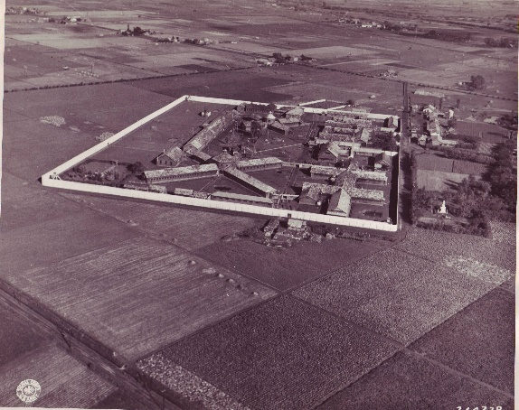
On 27 August 1945, Max Pestalozzi, the representative of the International Committee of the Red Cross in Japan, and three others began preliminary negotiations on the handover of POWs with the General Staff Officer of the Northern Command at the Sapporo Grand Hotel. At that time, they were informed of the existence of the “Tsukisamu Branch Camp,” along with the number of prisoners held at each camp at the end of the war. According to research by Hitoyasu Shirato, this was not a regular POW camp, but a collective name for two facilities, one at the former site of the 25th Infantry Regiment in Tsukisamu, Sapporo and the other at Sapporo Prison in Naebo, Sapporo.
Sapporo Prison at Naebo, Sapporo
The facility in Tsukisamu housed 12 US airmen who were shot down on the Chinese mainland and transferred to Japan.
The Sapporo Prison in Naeho held POWs convicted of committing violence or attempting to escape from the Hakodate District POW camps, as well as airmen who crash-landed on Shumusyu Island and were shot down off Otaru. They were transferred to the facility in Tsukisamu on 16-17 August, after Emperor's broadcast announcing Japan's surrender.
A short time later (probably 31 Aug), relief supplies dropped at a distance of 16-32 km were brought to the facility in Tsukisamu by truck. On 12 Sep, they were transferred by truck to Chitose Airfield, where they were on their way home together with POWs from the various POW camps in Hokkaido.

* Inmates of the military facility in Tsukisamu (12)

Front row left to right:
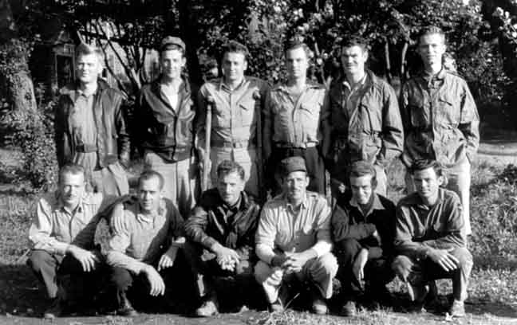
- 1st Lt. Freland K. Mathews
- 1st Lt. James Wall
- 1st Lt. Vern D. Shaefer
- Donald Quigley
- 2nd Lt. James Thomas
- Capt. Don Burch
Back row left to right:
- 2nd Lt Sam McMillan
- Lt. James Taylor
- 1st Lt. Harry Klota
- Howard
Aircrew from China
- 1st Lt.Walter A. Ferris
- 2nd Lt Sam Chambliss

* Inmates of Sapporo Prison in Naebo (11 in the list, but only 10 are shown in the photo)

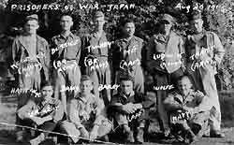
- J. R. Barridge: In February 1943, he was sentenced to five years' imprisonment for beating a watchman at the Hakodate Headquarter Camp.
- W.O. Charles Hattrick: In July 1945, he escaped from the Bibi Headquarter Camp and was sentenced to death.
- W.O. Herbert E. Turney: In July 1945, he escaped from the Bibi Headquarter Camp and was sentenced to death.
- Kirby Ludwick: He escaped from Utashinai camp in July 1945.
10 men from Sapporo Prison in Naebo
- Clarence E. Wolfe: He escaped from Utashinai camp in July 1945.
- 2nd Lt. Milton E. Zack: On 19 May 1945, he crash-landed on Shumushu Island and was taken prisoner.
- Cpl. Walter Bailey: On 19 May 1945, he crash-landed on Shumushu Island and was taken prisoner.
- Cpl. Robert L. Trant: On 19 May 1945, he crash-landed on Shumushu Island and was taken prisoner.
- Ensign Warren F. Langley: On 14 July 1945, he was flown in on SB2C from the aircraft carrier USS Randolph, crashed off Otaru and was taken prisoner. He was then supposedly transferred to Tokyo.
- 3rd Gunnery Sgt. Ernest J. Davis Jr.: On 15 July 1945, he was flown in on TBM3 from the aircraft carrier USS Bennington, crashed off Otaru and was taken prisoner.
- Ensign Cliford S. Mehelich: On 15 July 1945, he was flown in on TBM3 from the aircraft carrier USS Bennington, crashed off Otaru and was taken prisoner.

