Billie Edward Emerick
Unit: Searchlight, Wilkes Island
Survivor Interview
Date: October 10, 1997
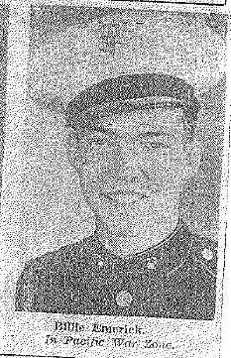
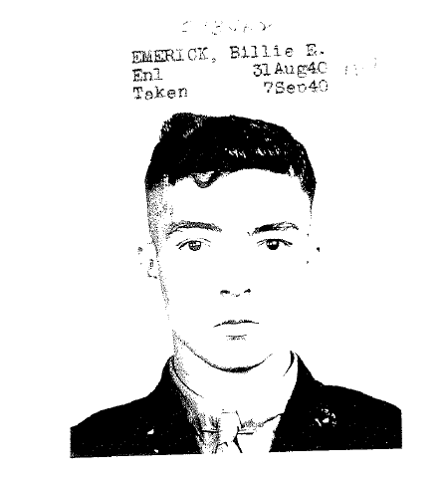

Q. If you could tell me for the record, your name, when and where you grew up? Just to put it on the record.

A. This going on there?

Q. Yep

A. Ok, my name is Billie Edward Emerick. I was born in Des Moines, Iowa, August 12, 1918. And that's where I grew up, went to school, and that's where I, well, actually it was West Des Moines, they changed the name of the town where I lived from Valley Junction to West Des Moines. And the town really blew up and expanded. And I come through there coming out here and you know I got lost in that town. It was so big and so changed I didn't know where I was.

Q. And that's where you grew up?

A. Yah, man, ok what else do you want?

Q. Can you tell me how you came to be in the marines?

A. Well,

Q. Start back as early as you, uh, can on that.

A. Well, got out of school, couldn't find a job. My brother was in the, ran a Standard Oil service station and things just went to pot all over, we wasn't making a living, sold out and and, uh I was talking to some friends of mine and they had both joined the Marines, and I said why didn't you tell me I have went with you, and they said it's not too late you can go down tomorrow. So I went down and joined, that's it.

Q. What had you heard about the Marines?

A. Ah, not much. I had just seen them movies, and of course that was fake, because you didn't get out of boot camp and go right away to saving people, there wasn't anything going on. And, uh, when I got in I liked it. But, when I got off the bus and saw that uh, big brick enclosure and the gates, I said what did I get myself in for? But, after I got in and got going, I enjoyed it very much.

Q. What year was this?

A. Ahh 1940, September.

Enlisted: August 31, 1940, 4-year enlistment. Recruiting officer: Capt. (ret). E.B. Moore. Billie departed Des Moines, Iowa at 5:21pm CST, on the Chicago, Rock Island and Pacific Railroad.

Q. What movies had you seen, uh about the marines, that you would have seen?

A. Doggone if I know now.

Q. I've heard of one called the Singing Marines, does that ring a bell?

A. Nope.

Q. Where did you end up in, uh, what was your first uh, boot camp?

A. San Diego.

Q. San Diego?

Billie was initially assigned to 2d Recruit Bn, Recruit Depot, San Diego, on September 2, 1940

A. That was, that was good, I liked that. And we done so much marching, about face that I wore out a pair of shoes in 3 weeks, I mean, well they weren't worn out, but I had to get them half-soled. And that's the first time I have had to get half-soles, because I had the heel taken off and full sole put on and then put another heel on when I got my shoes fixed. But ah man, that marching, that was good, it put strength in your legs, your arms and everything else. That's about it.

Q. What did you, in that period before you enlisted and so on, (pause) what was your impression of that situation, were you aware of what was happening in Europe and Asia?

A. Nope, and ah like everybody else I didn’t pay much attention to it because it didn’t include us, but everything else went to pot. But I’ll tell you one thing, we cannot police the whole world. Got to have help.

Q. Yeah, that’s true, so uh after your basic training what happened?

A. Well, then, uh, I don’t know, they shipped us from San Diego, where in the heck did we go? I can’t even remember what next. And then, uh, anyhow we ended up on Wake Island. And I liked it out there it was really good.

Billie arrived on Wake Island, 22 October, 1941, via the USS Castor, (AKS 1) with 15 officers, 373 enlisted.
Q. Where you ever in Hawaii, did you get, uh posted there for awhile?

A. Hey, that’s where we went yeah, we was in Hawaii and uh, I will never forget that because that song San Antonio Rose, well we’d walk down the street in ah San Diego, and that song was just coming in, and you could hear it in this tavern and this tavern and this tavern and this tavern (Gestures right and left), as you walked down the street and it hit you from both sides. And we went to Pearl Harbor, that’s where we went. We got over there and it was just catching on there and you walk down the street and it hit you from both sides of the road, man I still love that song. But uh, oh, I don’t know, uh, things were really going good. I felt good. I felt better then than I ever did feel.

Arrived Pearl Harbor, 22 February, 1941 via USS Enterprise.

Q. What kind of things did you do when you were in Hawaii, what kind of recreational things did you do?

A. Not too much, cause we didn’t make too much money. (Laughs) You can’t do much on $30 a month.

Q. That’s true.

A. Then we got $36, that was a big improvement.

Q. What was your first impression of Wake Island, do you recall what you thought when you landed there?

A. Well, I don’t know, but we couldn’t get off the ship when we first got there. And we would look over there and it look real close and a sailor said “You think it’s close”, he said “you want to see just how far it is don’t look at it straight, bend over and look at it from between your knees and you will get a better” what do you call it, well anyhow you can tell better where it is, farther or closer. I never knew that, but it’s true. And here we are it looked so close we just about jumped overboard and swam ashore because we didn’t want to stay on that Castor one more night, that’s the worst ship in the Navy. That son of a gun would just get up on top of a wave and just go this way instead of up and down, it would just bounce. And we wanted off of that as quick as we could get off of it. But we did get off the next day. And it looked kind of lonely out there. But, after we got used to it, it was fine.

Q. I can imagine.

A. Yep. I don’t remember if they was ready for us or we had to help build tents or what. No wait a minute, we was out at camp Elliot, that’s where we was and we had to sleep in tents because they was just building it then. Then we got shipped out, but those 18 mile hikes back into town from Elliot, oooh boy. Ah, it was just part of making you a Marine. Course we didn’t realize it then, we didn’t like it but it was for our own good.

Q. Toughen ya up?

A. Yep.

Q. What was your, ah, when you first landed on Wake Island, what was your, uh first duty assignment, what were you put to work doing?

A. Um, I think it was building air raid shelters. And they had a civilian camp out there, and we would go over there, (laughs) and steal their lumber. Cause we had a whole, and we put the lumber over the hole and then we put sand bags on top of that. So, oh what do you call them, it was about that thick, (gestures 3-4 inches) and about that wide (gestures 1 foot) and I don’t know how long it was but it would go clear across that hole. And that is where we could run our searchlight down in there in the daytime. And then we would pull it out at night. So we had to protect that searchlight too. And uh, Peepsight, Peepsight Hassig (Edwin F. Hassig) was our platoon leader, and they dropped a bomb and it blew that searchlight up and uh, he took it all apart and fixed it up and everything so it would work, but it didn’t work right. But that’s the only one we had, I mean us, there was others on the island. But he gets the credit for keeping it going.

MOS: Searchlight Crewman (763), under 2LT J.A. McAlister, Kuku Point, Wilkes. Battery L, Wilkes Island.

Q. Who else was in your platoon, do you recall?

A. Oh boy, I can see their faces, but I can’t remember their names. (pause) I can’t remember names anyhow, even today.

Q. Some people can’t. Some people can’t.

A. I remember faces. I can put a face, and somebody says that’s who it is, and I say yeah, that’s who it is. (Laughs)

Q. What were the uh, in your platoon, the various jobs people had, how did the labor break out?

A. Oh, we was doing a little bit of everything. Anybody that needed help, we’d help em. One thing I did not want is machine gun. Oh, hey, I just got out of boot camp, and they gave us an 18 mile hike in a machine gun company. What was it 2H8 or 3M8, or one of the two, I was in both of them, and they uh, made me 1st gunner on a machine gun. You know why?

Q. No.

A. So I could have the job of pulling that cart. And I don’t know how far we pulled it, and every so often they’d give us some rest. Ah, but I wasn’t the number 1 machine gunner, I didn’t even get to shoot it. But I was in the company, so, just a boot, that’s why I got to pull the cart. And uh, they say, never volunteer for anything, and I volunteered right out of that company right into a machine gun company because I didn’t know what 2H8 was or 3M8, whatever. And uh, then we was lined up getting ready to uh ah, go into dinner. And here comes somebody out and they said we are forming a new battalion and we need volunteers. I was the first one out there. And I got in that searchlight company. The best thing I ever did. Don’t ever volunteer because you never know where you are going what you are going to get into, but I did. And I loved that.

Q. What did you yourself, do in that searchlight company? What was your particular job?

A. Well, I was a truck driver, I pulled it around. You had to pull it up onto the, ah, well they had ramps to get it up onto the truck and it would carry your, what do you call those things that start up a gasoline engine and make electric?

Q. A generator?

A. Yeah! And we pulled a generator behind us and when we would get in and go out and shine the light at night and uh so the 50 calibers could fire at the towed targets. And we would turn the lights on and catch the target in light and the 50 caliber would shoot at them. And you was supposed to hit the target not the plane. Some of the guys up there got nervous and would just freeze, and that trigger was back and they would have to go up and knock them off of there so they would let go of it. That happened a couple of times when I was out there. And uh, that was fun. Course a truck driver, you don’t have to do too much work.

Q. Right.

A. I liked that. (laughs)

Q. What do you recall, what was your first memory of the actual battle?

A. Oh, you mean when the Japs come in?

Q. Yeah.

A. Oh, well, we was expecting, we had 12 planes, and uh, ah, when the Japs come in we was expecting planes, you know our own. And somebody said that their wheels are down, they are going to land, somebody said, I was on the phone, and somebody said one of those wheels just fell off and just exploded. What do we do now? I said, open fire. I don’t know how many planes we knocked down, but uh, all of the credit goes to Pearl Harbor, anything you say goes to Pearl Harbor, but I don’t recall them shooting any planes or sinking any ships, but we did. I think it was 29 planes we shot down, sunk or put out of commission, 9 ships. We sunk 1, oh that’s another thing I was on antiaircraft, and we couldn’t get the barrel down low enough, we’d get up there and hang on that barrel to get it down just to shoot our shells into the ship. And if they hit ‘em they would go in there and explode. One got a direct hit, the 5” said they did it, we said we did it, but that thing was like this, blew up like this. (Gesturing with hands) come back down and just went down like that. All within 10 minutes, it was gone. So we did our part.

Q. So you were on uh, antiaircraft?

A. Yep.

A. We’d use ‘em during the daytime, course you couldn’t use them very good at night. But uh, that’s another thing we didn’t have the right equipment either. We had uh, 3, I don’t know now if it was 3 directors, and 1 height finder or versa visa. But I know we didn’t have ah, one for each gun. You know, one complete outfit. So if the phones were working and the bombs didn’t break the lines, they would say so much elevation and this back and that’s the way we did it at night. Then they came over with some big 4 motor planes and they said don’t turn on your searchlight on because they were searching for the island. So we just didn’t turn them on, and they flew around and left. But those were big bombers they had. Most of the damage was done with dive bombers.

Q. What island were you on uh, during the battle?

A. Wilkes.

A. What is it, three islands, yeah, Peale, Wake and Wilkes. Three islands. And at night, you know, I had never seen fire at night and they was shooting tracers, and there I was trying to grab that red bird, whatever it was, (laughs) I’m sure glad I didn’t grab one because that was a 50 caliber machine gun. Well, I tell you, we had fun even though it was very serious. We had to have fun, because if you took it too serious you wasn’t worth a darn. You had to make up your own mind what you was going to do. You was going to live or die. And if you was too serious you died.

Q. During the 16 days of the battle did you stay with you line, or did you move around? (Female interviewer)

A. No, well, we had a big, well it wasn’t a foxhole, it was a big hole in the ground. And they had planks, I told him that we stole from the civilians, about so thick and about so wide, clear across the hole. And then they put sand bags on top of that. And we would run our searchlight down in there and pull it out. So we couldn’t move that around very much and still protect the light. But the civilians were good, they come over, uh every night and move the antiaircraft guns around to a different position. So the Japs knew where they were one day but when they come back the next day they weren’t there, they were someplace else. The civilians was really good at that. And we didn’t have all the power that we needed to move them. Because a lot of men worked on that.

Q. You ever spend any time over in the civilian camp? (Male interviewer)

A. Oh, we’d go over there and eat supper once in a while.

Q. What was that like?

A. Yeah oh boy, they had wonderful, good food. And we didn’t have that good of food cause so much a day, per person was allotted. And if you got $0.90 per day to feed 100 people, that was what $900 dollars? Or a week or a month, I don’t know. That wasn’t part of my job. (Laughs) But I do remember, uh, they said, we was, we was at breakfast, the mess hall, and an announcement come over that Pearl Harbor had been bombed. And I just went back to get another pancake, you have to take your plate up and they put one on so I took it off and put it underneath, and they put one on and I took that one off and put it underneath and you got another as you moved on down the line. And I had those pancakes when we went out to the gun position. Cause I was hungry. And that’s the only time we got to eat, right then and it was a good long time before we got another meal. And mostly, they’d bring us out some hot coffee, and maybe some soup. They had, uh, gas masks, I don’t know what you carry them in, but anyhow they was oval shaped like this and they was about that high. And they would fill that full of coffee and bring it out, or soup, or maybe both at the same time. And that’s how we ate. Course we had our canteen cups, and we’d fill that full of coffee and our canteen and we’d get some soup in it. And, uh, I never drank uh, or uh, used sugar at all and they say use all the sugar you can use because that gives you a lot of energy. So that’s why I started using, I’m still using sugar today.

Q. Gives you that boost eh?

A. Yeah.

Q. Do you, uh, what did you or what did you know much about the Japanese before the war?

A. Nope.

Q. Were you told or talk about what kind of soldier they might be, or the society or anything?

A. No. I never paid them any attention. Oh one thing, where was it? I think we was still in Pearl Harbor, cause I had a Sunday paper, and it was all about the Japanese, if it ever come to war they could knock the whole navy out in 3 weeks. 21 days. Took ‘em longer than that to find them. (laughs) So it lasted for a good long time. But I tell you, they are warriors! (pause) And they’re good ones. And I’d like to tell ya, some of ‘em come ashore, and we see them come ashore, and they had shoes, rubber shoes, rubber and canvas, and they had just like a mitten, you know, a mitten that has a thumb hole and all your fingers are here. (demonstrates with hand) That’s the way their shoes was. And we called them tree climbing toads. (laughs) But they was weird coming up out of the ocean. But some of them had to swim to get there but they got it.

Q. You saw the landing, when they?

A. Yup. uh, one, they set one destroyer on fire, it just kept coming back and forth, and back and forth and back and forth, they was asking for it. And we hit that thing and it was on fire so they beached it. So it wouldn’t sink. And, uh, that was there for a long time. Even after the war, it was there. And then the Japs come, and after that, they come and got all that stuff and took it back to Japan and used it for scrap iron. (pause) uh, the first Jap I ever shot was just like trying to pull a tree over with your finger. (gestures) I couldn’t pull that trigger. You’re not suppose to pull it, you’re suppose to squeeze it, you know, but I wanted to pull it. But after that, it’s just like hunting rabbits. First one just like hunting rabbits, ptwet bang, get ‘em. And I had, I hope they won’t uh, fine me for defacing my rifle. (laughs) But I had seven notches on it.
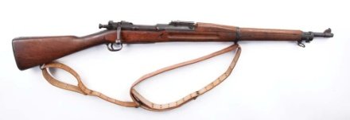

Q. So, tell me a little bit more of the landing, this was the first or the second time they came ashore?

A. First.

Q. First time?

A. (nods head, yes) uh and you know what they say, you never hear the one that gets ya. I heard the one that missed me. Because that thing, bang, right in my ear. Psst, it was gone. I’m glad I heard it. And then uh, my squad leader, and one other guy was over behind a truck, a dual wheels, and I knew there was some shooting going on over there. And I tried to sneak up on ‘em, but I made a mistake, I had the bayonet on the end of my rifle. You don’t do that when you are hunting, when you are trying to fire and look around too because, it’s (gestures) you know, throws you off balance. And here this guy come a walking, ah his name was uh, almost like mine but his was Himelrick and all of a sudden he just fell over, kicked his feet up, he was dead. I’m not glad that they killed him, but I’, glad that they hit him instead of me. Then, I got down on the ground too. And I took the bayonet off so I could swing it around and do a better shot. One guy, they had a great big rock, oh I mean it was as big as a room, right on the edge of the beach. And there was uh, Japanese, uh, well he was, he was back there and he was sticking his gun out like this, rifle, excuse me, and fire and bring it back, fire and bring it back, fire and bring it back. And I figured, I’m going to get that guy. And I sat there and aimed right there where his rifle was, and he stuck it out and I fired and he bring it back. The next time he stuck it out his bayonet was only about (gestures 3-4 inches) only about that long. I was trying to hit the uh rifle itself so that he couldn’t shoot. And then here come another guy he walked up on that rock, (points down) bang, there was no more firing. So they got that one. But I was trying to hit the stock of the rifle, then it wouldn’t work, knock it out of his hands, and all I got, he brought it back too quick and I got the bayonet off of it. Oh there is lots of things that uh, I just put them out of my mind, because if you dwell on it too much, you won’t like it.

Corporal William C. Halstead was credited for climbing up on that rock and killing the three Japanese SNLF soldiers. Source: Schultz, Duane. Wake Island, the heroic, gallant fight. New York, New York. St. Martin’s Press, Inc. 1978

Q. Yeah, sure.

A. So since then, I’ve just been trying to put everything out of my mind.

Q. What do you recall, uh, of the second landing, the second invasion?

A. Oh, that’s when they come in to stay, yeah! The first time they didn’t know we had any firepower out there and we sunk some of their ships and they took off. Coming back, they come back to stay, cause they had a lot of ships out there, then. I don’t know how many it was, but everywhere you would look you would see one. And their planes was coming over too. And we was out there trying to fire the antiaircraft. And I remember, there was a lever on there, (looks up, and gestures with hands) and you got to turn it one way and that thing backfires, er uh, you know when they fire it would knock it down, kick out the shell, and it would go back ready for another shell and this time the lever was wrong and the shell wasn’t kicked out, and everybody run. Ah, you can get that shell out by pulling a lanyard and it will open up and it will come out. I was stepping up there, they have a fuse cutter on those shells, you stick it in there and turn it around for as many, uh seconds as you want it to go off. And I put it up there, my job was to take the shell out of the fuse cutter, put it in, and I’d ram it in like so. And then the block would come up and block it, and they would pull the lanyard and it would fire. Well, I did that one time all by myself. Then I took off, cause there was a plane coming over and there was bullets hitting all over the platform on that antiaircraft gun. So I took off, and there was uh, hole over there, a little bit bigger than a bushel basket, and I got in that hole and I was all bent over, my ears was between my knees and I just laid there. Uh, when they drop a bomb, a bomb don’t explode straight out, it drops and it explodes this way. (gestures up and out). So a bomb could hit me, err pretty close and all it would do is just jiggle the rocks in on top of me, and it did that a few times. And uh, then the all clear went, and they come over, (laughs) and a friend of mine, that I was in a foxhole with says, “Oh, God they got Emerick, look at that”. I said, “They got me, hell, I just can’t get out of here?” (big laugh) I said “I’ve been here so long I can’t move.” So they helped me out. Everything was alright. He is still my friend today, he is here now.

Q. And you were just doubled over so much you couldn’t, you couldn’t get unbent, you couldn’t get out of there. (female interviewer)

A. Yeah! Well it’s just like you drive a car too long your legs get stiff. When you first get out it’s hard to walk. My legs are bad anyhow.

Q. What do you recall about the end of the battle?

A. Oh, well, yeah, we was down there uh, still shooting at planes. And we didn’t know it. But pretty soon, here come Major Devereux and he said “Throw down your arms, we have surrendered.” We didn’t believe it. We was still shooting, at uh, shooting the rifle at planes as they would come over. One guy, was on a machine gun, and they shot at him and oh boy he was like, pew, get out of there, (gestures) and I think that was the last. And they come over and uh, Major Devereux had a sheet on a 2x4 carrying a white flag. And he was kind of frail to be carrying that, but it’s what he had to do. So, we just threw down, but I did take the bolt out of my rifle and throw it away. So I couldn’t just lay it down and let ‘em have it. Oh, there was a, yeah there was a hole there, a bomb hole that had water in it, and I threw the bolt of my rifle in there.

Q. What happened next?

A. That’s just about it. They just rounded us all up and marched us over to the airfield. And of course they would search you, pat your pockets, take your billfold, take your watches, take your rings. We got out there on the, the airfield. They told us what to do and what not to do. And they brought us water to drink out of a barrel that had gasoline in it. They dumped it out, put the water in, so it tasted like gasoline. And uh, we sat out there in that hot sun for, well all that day and all the next day. We didn’t dare move cause there was machine guns about every five or six feet pointed right at us. And if we’d moved they would have fired. And then uh, they said that they would have ships here to take us off the island and, but I didn’t know what they was talking about. We thought it would be the next day, but it was a few days later than that. And uh, I had a notion that I was going to hide and not get on their ship. They’d sail away without us. But they left men there, and if you would’ve stayed there you would have got shot. In fact, I don’t know where these other ships had been but they had been out on maneuvers and they had few ammunition left and as they come over, past Wake Island they just unloaded the ammunition. They wasn’t shooting at anything, the just unloaded on the island. And um, there was some workers left there to run their uh, oh they got ocean water, what do you call that, what they do desalinization.

Date and Time Billie became POW: 23 December, 1941, ~2:00PM.

Q. Desalinization

A. Yeah. To run that machine that did that. And some other things that the Japs didn’t know how to run. They left them there to run that for ‘em and when that ship unloaded, they took those guys out shot them down dead. Because they was mad because they, after we had surrendered other ships had shot at them. And that’s about the end of it. (wipes his left eye)

Q. When you were on the airfield those three days, what did the Japanese tell you, you could and could not do?

A. Uh, not to move. If we had to go to the toilet. It’s not a restroom, it was a toilet, (laughs). Uh, you stood up and you hollered “Benjo”. That’s toilet to them. So they would let you go. But then there was people would, going with you so you couldn’t do anything but go to the benjo. And uh, course we would only do number 1. (Holds up hand with 1 finger up). Because we didn’t have enough to eat to do number 2. (Holes up hand again with two fingers up). So, we was uh, we had water and that’s about all for three days.

Q. Did you talk among yourselves at all?

A. Oh yeah, quietly.

Q. What were you talking about?

A. Anything we could think of.

Q. Just to keep busy?

A. Yup. And uh, we made up our minds that we wasn’t going to rush those machine guns. Because there was too many of ‘em and you would never make it.

Q. What were you thinking, (pause) at that time, if were you predicting what was going to happen? What did you think?

Date departed Wake: 12 January, 1942 aboard Nitta Maru for Yokohama, Japan. On 18 January 1942 the Nitta Maru arrived in Yokohama Japan. The Nitta Maru departed Yokohama on 20 January, 1942. Nitta Maru arrived at Shanghai at about 2:30 or 3:00pm on 1 February, 1942.

A. I don’t know, just kind of numb. Everybody was scared. But, they didn’t let on to the Japs of being scared. And then finally, oh that was a beautiful ship, showed up. Took us to Japan, no, took us to China, and we was in China for I don’t know how long and then they started shipping us out to Japan. Where ever they, well they uh, wanted to know what you could do. Ah, machinist, mechanic, whatever. And that’s the ones they wanted in Japan so that they could work there and their men could be in the army. So what we was, was slave labor. They’d get ah, 20 cents a day and we got two days a month off. Let’s see, the army gave us a day off and uh, the people that we worked for, the factory, they give us a day off. So they’d put them together and we had two days a month.

Q. Do you recall the camps that you were in, in China?

It was 35⁰, dressed in tropical clothing the prisoners marched to the POW camp. It took the POW’s about 2 hours to march the 5 miles to their first camp. Source: Urwin, Gregory J. W. Victory in defeat: the Wake Island defenders in captivity, 1941-1945. Annapolis, MD: Naval Institute Press, 2010

A. In China, I think it was Woosung. That was an old, uh cavalry training ground for the Chinese. And we moved into their barracks. And when we moved from uh, Shanghai we had to march up to, up to, to where the barracks was, it was about 15 miles. And we marched right out into the middle of a muddy field. In front of the barracks, and then they got up there and they give a big speech. And then it started raining, so they out us in the barracks. And uh, we didn’t know who, who was who, we just walked in. And then pretty soon they brought us some food, some rice. And it was, and, it was good uh, but it was hot, hot, with some kind of a seasoning and we wasn’t use to it and we couldn’t eat it. You know eat some and it was just too hot eat. So, all we could do was pour it back into the bucket that they brought it over in. And from then on they didn’t give us that much. But then it was cooler too. You get uh, two meals a day. And at noon, they’d give you a little small, they called it a loaf of bread but all it was, was a bun, something like that. (gestures). And we just sat around and did nothing. Then one of the officers, I think it was McKinstry, (Marine Gunner Clarence B. McKinstry of Battery E) I don’t know whether he was an officer or just a high sergeant, but he took money out of his pocket and told ‘em, you go to town and buy some seeds and let us go and make a garden and we cannot call on you for food, but we can raise some of our own food. And uh, so that’s what we did. And uh, big spaces out there, well, the whole field, but we dug it up by hand and made garden. And we’d go out every day and work in that garden. There was nothing to do but go out and pull a little blade of out of it, you know, (laughs) everything was done by hand. And somebody got the idea of pounding some ah, spikes in a plank and put some rope on the end of it and use that to make uh, everything smooth. And, there was only so many could work on the garden and we sat there with our feet in a ditch, and then every so often they would come over and sit down and we would go back and pull grass, there wasn’t any weeds. Because it didn’t grow that much, but to them we was working so that’s alright.

Billie was in Barracks #2 Woosung Prisoner of War Camp.

Q. What kind of things were you growing?

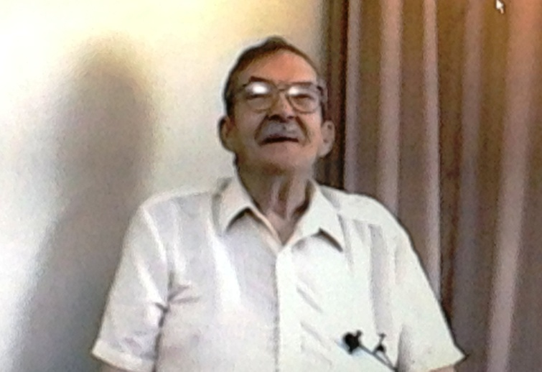
A. Beans, mostly. Not green beans, uh, oh, what do they call them, no not lima beans, the brown ones. Too many beans for me to remember. (pause) Just all kinds of things. And uh, then when it was time to come in, ah the sergeants, ah platoon sergeants they would come out and get us. But our’s (smiles) he had a voice that would carry a half-a mile. So he just came out part way and he would get our platoon, and he would just holler at them what to do get up, come out, turn around, come on, march in, so we was always the first ones in.

Q. Was there, was there any other time when the Japanese had you doing other kinds of labor there?

A. Ah, yeah. Some of the civilians was out there and they was polishing shells. I mean uh, that the Japs had, I don’t know they was 3 inch or something. And they’d give them rope. And they would, I don’t know how they held the shell down, but they would take rope and pull this way, (gestures moving arms back and forth) you know, and shine that thing. Then they’d turn it around and shine the other side. I don’t know how they cleaned the inside. But they was, that’s what the civilians was doing. And uh, we couldn’t do it because that was against the uh, Geneva Convention and the Japs said we didn’t sign that so we don’t have to obey it. But anyhow, they didn’t make us polish shells. Just the civilians. While the civilians was out there, we was in resting. (smiles and laughs). It was funny, yet it was serious. But we made fun of a lot of things, you know. Make up things to make fun, of so that you didn’t get too serious. A friend of mine, uh, and the reason I uh, got his acquaintance was when my brother was in the navy, and he was on a submarine and uh, when this guy come in was in a submarine that they, I don’t know how they captured him. But anyhow, he had been on a submarine so I made friends with him so that I could talk about , you know, what submarines was cause I don’t know what anything about ‘em. Only when I was back there in Pearl Harbor I walk ah, I walk ah nights, patrol, go by them submarines, and big old black things out, tell you it was spooky just to see ‘em. So anyhow, I got acquainted with Rasmussen and we’d talk about submarines. And uh, he killed himself. We, go to work, and he was, he got sick, and he said, “I cannot work on this food I can’t do it, I should have told my wife back in Seattle, that uh, I should have told her about this, I should have told her about paying the taxes, about keeping the house up and this.” And I said, Ras do not worry about your wife, she’s back there with plenty of food. He said, “Well she smokes a lot.” I said well, she got cigarettes back there just because you don’t have ‘em here, they got plenty there. I didn’t know that they were rationed. But anyhow, trying to cheer him up a little bit. And I don’t know how long we was together, they finally got him, in the hospital ‘cause he got too weak he couldn’t do anything. But he could have done it if he’d have put his mind to it. But he was laying there on the table with the liberation party come in. You know, he looked up like this and said, “Oh, I’ve just been waiting for you guys.” Pfffft! (puts head down). Dead, just like that. He weighed 86 pounds. And he was about 238, or something like that, bigger, you know when he first come in there. Well, I was up around 240 myself. I know I was gaining weight, cause my pants was getting tighter. (laughs) So that’s what I was, and uh, when it was over I weighed, uh, 98 pounds. You see the pictures of the Jewish people that was at the prison camps, how you could see their ribs, this bone right here) (gestures to clavicle), collar bone that. I looked like that too. But, I told myself, I wasn’t going to let them kill me. And that’s the only way you could do, just say no, no, no, no.

Billie is assigned Prisoners of War & Missing, Persons Detachment. HQMC, 19 June, 1942.

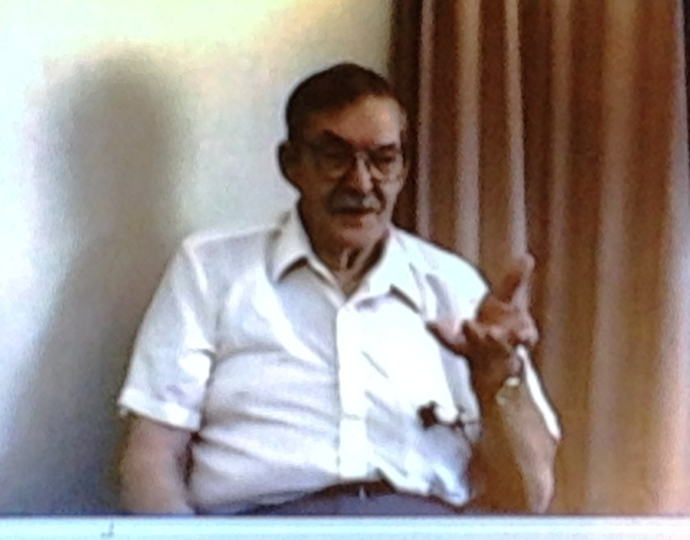

Q. When you, were shipped out of China where did you go?

A. Japan.

Q. Do you recall where?

A. Umm, we was in two different camps. We was uh, I don’t know whether it was Yawata or Tobata. But, we went over there and they put us in, what we called it the “White House”. And it was uh, an old hotel. And uh, there was what ah, I think there was twelve or fourteen people in a room. They both had their own beds, but they was just straw, mats that you slept on and one blanket. And you had to sweep the floor every day. Then, they took us to work on a train, and it wasn’t chair cars, it was box cars. You stood up all the time. And uh, I don’t know where it was that they took us cause when it was a big factory there. And then they’d bring us home on the train at night. Then we’d have to walk through the town, or was that the next time they moved us, no, oh yeah, it was pretty close to the motel er hotel. Then we’d go back and take a bath and go to bed. But they’d give us a little bowl of rice, but then when we started working we got better food. Because the factory, I mean they furnished part of it, but uh they wanted to keep us strong so we could keep working. The Japs wanted to kill us all. But uh, the owners of the company that we worked for I don’t even know what the name of it was, ah, they wanted to keep us strong. And they wouldn’t let anybody bother us while we were in there.

Roger Mansell’s excellent database shows that Billie was one of 36 Marines to leave Woosung for Japan in November 1942. YAHATA Provisional POW Camp, also called the “Citadel”. 2nd Hellship, Miiki Maru.

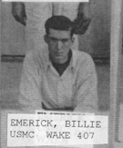

Q. What were you doing?

A. Well, uh, what I was doing was making files. Now they’d take old files out and they’d heat them up and what they did, they called it annealing and they would soak ‘em in acid and that would soften them, and they would take them out and run them through a, uh, ah you know what a grinder is but this was a barrel grinder, it was like this, you know, (gestures in a large circle) and hollow in here and then we would just run that file down through there and uh, smooth it.
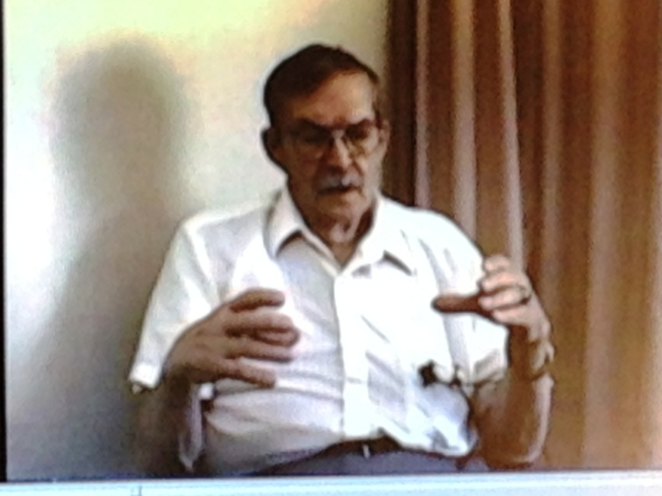

And then turn it over and then run it down through there and so that it was clean you could stamp new teeth in it. And I did that, and I run the stamper, uh well first before I run the stamper. That was a big machine that comes down and bang, bang, bang, and make new teeth in it and then you would turn it over and uh do the other side. And you know the way they did it was crazy. Because uh, they would run that stamping machine with their right foot, here, we could step here and run it this way. And they wouldn’t let ya, you had to do it this way. Man that’s crazy. And uh, man your back would get, the machine was only about so high and you had to bend clear over so you could see where that thing was going. And uh, well we was always complaining about our back being so sore, so this one guy that was our pusher, that’s uh, same as your boss, we called them pushers. He come over and I was always doing this, (gestures straightening back and grimacing) about my back and I told him, I couldn’t talk Jap and he couldn’t talk English but I told him, lift the machine up and we don’t have to bend over so far because the Japs they were short, it was alright for them. But for us it wasn’t. So, he said, “no,no,no”. Couldn’t lift the machine up. So anyhow, we went home and come back the next day. They had dug a hole, in front of it, about this deep, (gestures ~1 ft). So we could stand in the hole and run it and not have to bend over so much. So they did help us. But not the army. Then I had a job, those uh, files when they come out of the grinder, it ah, it wasn’t exactly smooth, you’d take ‘em up and put ‘em in ah, ah vise, ah, flat-wise, and they give you a little tool and you scrap them down, like this, (gestures rowing-type motion back and forth) It was just like a draw knife. And then they gave you a little thing to make sure it was straight across. That was ah, not too bad. In fact, I kind of liked that because it was strengthening my arms, it was pulling like that, (gestures). And so I did everything but heat ‘em, and treat ‘em afterwards. They weren’t new files. They couldn’t afford new files they had to re-stamp the old ones after grinding the teeth off. It was pretty good. That was about then, the only thing I done in a factory. Ohhh, then they took us outside and uh, we dug, I don’t know, we dug a hole about 10 to 12 feet deep, I don’t know how big around it was. And then, they, filled it with uh, ah sort-of-like cement blocks, but they weren’t like we have cement blocks. And then they made a hole about like this wide, (gestures 8-10 inches with hands) and filled that full of cement to shore up the roof, and that’s when I learned to tie, uh, rod, that you put in, I don’t know what you call, that rod that they put in?

Q. Rebar?

A. Rebar, yeah, and I learned how to tie that. That was easy job, just put a little string around there, turn a little wheel like that and tie them together. Then, uh, we poured cement on top of that. And that give the office help a place to go in case of bombing. They never had to use it.

1 January, 1943 renamed FUKUOKA POW CAMP YAHATA, (YAWATA) Branch Camp @ Nakamachi, Yawata City.

Q. Do you recall what city you were in or near when you were working in the file?

A. Either Tobata or Yawata. And I can’t remember which. But uh, then they moved us. Instead of going back to the hotel, they built a barracks for us to move in to. All out of pine, that, some of it still had the bark on it. And you know bed bugs live in the forest in pines.

13 December, 1943 moved to KOKURA-shi, OAZA NAKAI, AZA YAKURASHIMO, still called Fukuoka #3-B.

There were twenty-four camps named Fukuoka, after the prefecture in which they were located. Each was numbered one through twenty-four, and some of the camps had been given additional names, denoting the area in which they were located. Fukuoka #3 was located in Yawata, near the Dai-Ichi Seiko steel mill. Source: Pearson, Judith, Belly of the Beast; a POW's inspiring true story of faith, courage, and survival aboard the infamous WWII Japanese hell ship Oryoku Maru, 2001 New American Library, a division of Penguin Putnam Inc., New York, New York.

Q. Uh huh.

A. And that’s where we got bit by bedbugs, I never, I didn’t even know what one looked like until we got in there. And people was waking up all bites all over um, (pause). Um, then they was complaining so much about it, they’d give you a reward for 50 bedbugs. Man they was sticking nails and everything else in the cracks of the wood to get a bedbug out of there. And they would turn their mattress over and there was about this thick, (gestures ~2 inches). Oh it was about this thick, they called it a mattress, but it was just a pad is all it was, that’s what they slept on. So that’s what we slept on. And uh, they was just really cleaning house. And I forget what the heck we was doing then. Then they had us out uh, scraping a field where they had uh, iron ore, ah, not iron ore but whatever it was, rocks and everything else, still had a little bit of iron in, we was out cleaning that stuff up. After that, we had a little basket there, filled the basket full of that. Go over and drop it off in a boxcar, not a boxcar but a coal car, that’s what we called ‘em. And uh, oh that was out in the open so that was good. And then there was a time, I never seen ‘em, put ore that had been used, you know they heat it up and iron comes out, of the rocks. Well the stuff that was left over they would bring that out there and they would dump it into the bay. And boy, the first time I heard one of them, when all that stuff hit that, oh God it sounded like bombs going off. And it was just exploding all over, cause that stuff was white hot. And when it’d hit that water, oh man, then we got to enjoy it, you know. Hey, here comes some more bombs. (laughs).

Billie’s parents were notified Billie was a POW on 15 May, 1943, almost one year after he was transferred to Fukuoka, Japan. On 2 October, 1943, there was a War Department memo informing family that Billie has been transferred to Fukuoka Prison Camp, Japan.

Q. You mention helping build a bomb shelter, did you see any bombing around where you were there?

A. Nope. But, we didn’t see it, we heard it. Ah, what in the heck, we was, anyhow they built us a building, and they used it after we left and then we had bomb shelters, we built our own. Right into ah, what do you call them, a cliff. We’d dig out like this, and then they had ah, bamboo woven like this and, stakes going down and you’d weave it in between them. And then the stuff that we took out of that hole we would dump in there. So that if a bomb hit out there it wouldn’t come into the cave. And we had to go in there every night. Because the bombers would come over and uh, where in the heck was that, it was right on the bay. I don’t know either Yawata or Tobata one of ‘em. And um they had a garden over there and at night we’d go out and steal stuff out of the garden. We’d have got caught, we’d have got shot. But at least we had something to eat. And um, then over to the uh, to the left of us, they had a great big, great big power plant. I don’t know how many smokestacks they had there, now whether it was four or five but the bombers would come over and they never touch that thing. Because they was using that as uh, uh spot on the map where they could come in to that and then they’d know which way to go from here to there. That’s what they were using that for. So they never did bomb ‘em. And uh, one night, and a bomb got loose boy and it landed close by and the next day. And I got so, I didn’t want to go to that air raid shelter because you had sand fleas in there and when you come out you was just bit all over. So they said go to the shelters. And, uh I said, the heck with it, I just laid down up against the wall so they couldn’t see me, they looking, nobody there. So they went to the shelter. And I just laid there. (smiles) You know they got ah bomb that didn’t go where it was suppose to go, and it landed pretty close to our barracks. And the next day they set it off and there was all windows up above here and the next day they set it off and it just blew them windows out. So that I’d have, that if that have gone off I would have got it. Oh, I wouldn’t have got killed but I would have got cut pretty bad, just from the glass. And uh, then after a while they just quit shooting at the B-29’s because they wouldn’t go up that high, I mean their antiaircraft would go up that high so they just quit shooting at ‘em. And uh, one plane in the day time come over, they had an air raid, here goes the Japs off to the air raid shelters and the heck with us. So we was out there, (laughs) we was out there watching we was just having fun. I don’t know whether it was a B-24 or a B-25 come over, it must have been having trouble because it just kept circling, circling, getting lower and lower and then pretty soon there was just a big white flash up there. It blew up, I mean they’d hit it with a shell and it blew up. Then uh, another time one come over and it come over awful low, and it was in trouble and it kept going until it was out of sight, and then you didn’t hear it blow up but you could see the smoke coming. So ya knocked it down, you know it was on fire. And uh, anyhow, they was dropping us stuff, um, let me see, I don’t want to get ahead of it, yeah, they come over and then they was dropping food to us. And they was dropping boxes but when the parachute would uh, you know, drop it out, well the parachute would jerk those boxes and the straps would break and they would just go all over. And some of it on the ground and some of it up on top of that uh, power station. And the one’s that went up there, well this was pretty close to the end now so they didn’t care what we did. We run away they didn’t care. And um, we’d go up there and get those boxes. (pauses) Your tape quit?

Q. Yeah, we need one more

A. So we went up on top of that uh power plant, and we would, uh get a lot of food up there. And if a can, well they didn’t explode or break, but the lid would just uh, bend and then you could get a finger hold in it, we’d tear that whole thing off bare handed, cut our fingers, we didn’t care and reach in there and just eat that food. Just uh, like a monkey, just keep going like that, (gestures a scooping motion into mouth) because we couldn’t get enough food. And uh, one of the boxes broke loose, now this was pretty close to the end, ah, box broke loose went right through a guard shack out in front of the gate, killed a guard in there cause it went right through the roof and killed him. And uh, oh I don’t know, we felt kind of sorry because he wasn’t doing anything and he had a wife and kids, we found out later.

Q. Now this, you were getting food was this before the end of the war?

A. No this was right at the end of it.

Q. At the end huh?

A. Ending it. And uh, pretty soon it was over. And our, uh, now this guy Nichi he could speak better English than I do. And we talking to him and he said where you from? Well I said, he didn’t know where West Des Moines was, or Valley Junction. I said oh, Des Moines, Iowa. “Oh he said you got Drake University down there.” He talked good but what he was he would come over and buy scrap iron and then he would go back with the scrap iron and then his folks was sick and he come back from vacation, and the war started and he couldn’t get back to the states anymore. And he was a nice guy, he’d help ya. And uh ask him for a cigarette, “oh here take the pack.” Well, you’re going to need some? Oh he said I get them from the dumb bastards, he says they are dumber than hell anyhow. He’d cuss his own people. He was on our side. But I mean, you know, things like that you remember. And it’s funny, yet it’s serious.

Interpreter Hiroichi Nichi, 5’5”, approximately 165lbs, 35 years of age. Good to POW’s, per, Stanley M. Corbett summation and Joe G. Ingram affidavit.

Q. Do you recall, towards the end of the war some of the, you aware of some of the bigger events? I sometimes ask this question, when Roosevelt died for example. Were you aware of that?

A. Yeah, we knew.

Q. How did you find out?

A. Ah, Nichi told us.

Q. This was the guard at the ah?

A. No, uh the interpreter.

Q. The interpreter huh?

A. Yeah. Oh, he was good. He could speak better English than I do.

Q. And where was he working, he was working in the camp or where was he?

A. Uh, no, he come in when we come home from work. And he said, “I have some sad news for you folks.” And we was prepared for the worst. And he said, “Your president, president Roosevelt has died.” And that was about all there was to it. We moaned a little. And that was pretty close to the end.

Q. Yeah, now this interpreter, this is interesting, you, where was he, was he part of the camp? Or what?

A. No he was working for the army. To, to spy on us, I guess, and tell whatever it was, I don’t know whether he was working for the army or the company. But he was a nice guy, he helped us a lot. But that was his job coming over here and buying uh, ah, scrap metal. Then we had another one, (scowls) called him Ishiari, We told him, we told him he looked like um, one of our famous movie stars. Oh, me a movie star? He couldn’t talk very good anyhow. And uh, Oh me movie star. (laughs) Mortimer Snerd. (laughs) Oh, I Mortimer Snerd, I big movie star. And uh, boy when he found it out who Mortimer Snerd was, ohh God he was mad. He didn’t hit anybody, but he was mad. Uh, you know, it was, funny things like that stick with ya, (pause) as bad as it is. Ah, another thing I going to tell ya, and I hate our government for doing it, it’s a B-24 or a B-25 1 crashed, and they took these people in and I was in the same hospital, had to get a fish bone taken out of my throat. And they took it out and they was very polite and then the guard took me back. But you know what they did to these guys that was on the bomber? They done experiments on ‘em. They’d tie ‘em down and they’d cut ‘em open. No anesthetic or nothing! And they would fill them full of salt water to see if salt water had uh, same effect as uh what do you call stuff they put in bottle?

The Beast of the East, also called G2: Isamu Ishihara, the chief interpreter. Was very mean, frequently slapped, beat and applied water torture to the POWs. This was at Woosung Prisoner of War Camp, Shanghai, China.

Q. Saline?

A. Yep, saline. To see if it would take the place of saline. One of ‘em, they cut open, and they reached in and got his heart and held it, so it wouldn’t beat. Killed him. (gestures throughout description). All these experiments, the government didn’t do a thing, they let ‘em go. All they wanted, was they uh, uh results of their experiments. Those doctors should have been shot for doing what they did. But, that’s not the way our government works.

Q. How did you hear about the end of the war?

A. Ah, Nichi, told us. He come in, and he said, uh, well, we knew that they had dropped the bomb and we didn’t know which one. Was it, was it the first or the second. And they told us, and that’s the first time that my pusher ever slapped me. He come up, and I guess I didn’t bow or something and he hauled off and slapped me. And, I didn’t know what for, I thought well, that’s the way they are. And uh, that’s because they dropped the bomb. But they knew how many people was killed, we didn’t. And then when they dropped the other one, Nichi come in and he said, “well boys, you don’t have to go to work tomorrow. The war is over.” So we was glad to hear that. But then it took us about ah, oh I guess 30 days before they could get transportation to take us to Nagasaki, to get on a boat and go home. They had the boats there. And but they couldn’t get it organized, you know to uh take us all up there on the train. Finally, got us up there and got us on a boat. And we took off. And, uh, I don’t know which one it was, but uh, people on there they gave ‘em, well they tried to be good to ‘em, they gave ‘em whatever they wanted. One guy, I think he ate 26 eggs and 12 slices of toast. You know what, he died.

Q. Sure.

A. And there was one other guy and he ate too much like that and he died. So then they put a limit on it. They wouldn’t give us too much. But you know, (laughs) boy, and you’d take your tray, and you go up and it’s got holes in it, they’d put potatoes here, and beans here, and something else here, and uh, I walked through there and all I saw was beans. I don’t want any beans. And I kept going, and that’s all there is, is beans. I had to go through the line again, and I said, give me some beans. (laughs). But they didn’t give me too many cause then, then they was trying to take care of you to keep you from dying from eating too much. But they’d give you whatever you wanted, if they had it. But you know, I still like rice.

Q. Really?

A. Well, our rice is just like their, ah no, their rice is just like out potatoes. So it’s the same thing. But I wouldn’t eat it for a long time when I got home. Then my mother made some, ah, rice pudding, that was good. So, now I like rice.

Q. Well, thank you. This has been really good. I appreciate your talking with us.

A. Well uh, we had ah bad times and we had good times. Even at the worst times, we had good times. Cause we would not let ‘em get us down. If they’d , if you let ‘em get you down, then you’re done for.

Q. I guess that’s the lesson.

A. Yeah.

Q. Thank you.

A. Make fun at the most serious things.

Billie Edward Emerick was repatriated on 13 September, 1945 by Major Winnifred O. Davis.

20 October, 1945 Billie was admitted to US Naval Hospital at Oakland California.

Diseases from Billie’s service record: Per G.S. Frauenberger, Lt. Comdr. (MC) U.S.N.

Pellagra,
Beri-beri,
Malaria
Fungus Infections
Eczmetoid lesions on both hands, diagnosis changed to Dermatitis.

Medals, citations and commendations:

1). Presidential Unit Citation with ribbon bar and bronze star
Medal Number 8394, 4 January 1942. (Only Presidential Unit Citation signed by FDR).

2). Commendation from Lt. General, U.S. Army, Chief of the Army Air force to Major General T. Holcomb 17th Commandant USMC. 7 January, 1942. “..inspiring report on the activities of the small group of Marine Officers and ratings in the gallant defense of Wake Island.”
3). Purple Heart, 8 October, 1945.

4). Good Conduct Medal, 10 December, 1945.

5). American Defense Service Medal with Base clasp, Asiatic-Pacific Campaign Medal with one bronze star. 3 August, 1946.

6). Victory Medal World War II, 3 August, 1946.

7). Promoted to Corporal 5 November, 1945, “For purposes of seniority Billie’s service record from Corporal will be dated December 22, 1941.”

8). Promoted to Sergeant, 2 February, 1946.

9). Honorable Discharge, Series A, A228034. 27 April, 1946

10).19 November, 1946 Letter from President Truman welcoming POW’s back to the United States. ”You have fought valiantly and have suffered greatly. As your Commander in Chief, I take pride in your past achievements and express the thanks of a grateful Nation for your services in combat and your steadfastness while a prisoner of war. May God grant you happiness and a successful future.”

11). Prisoner of War Medal, 1 March 1988. (43 years after repatriation)

Date of Death: 11 November, 1999.

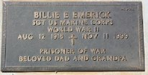

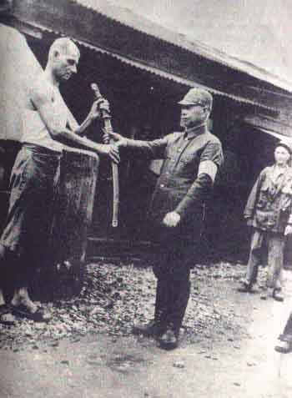
Commandant of Fukuoka 3B, Japan, Major Yaichi Rikitake was convicted of War Crimes and sentenced to 15 years hard labor. Docket No./ Date: 15/ Mar. 7-22, 1946, Yokohama, Japan.

Chief Medical Officer Fukuoka 3B, Seitaro Hata, sentenced to 25 years hard labor. Docket No./ Date: 53/ May 1 - 28, 1947, Yokohama, Japan. No picture available.
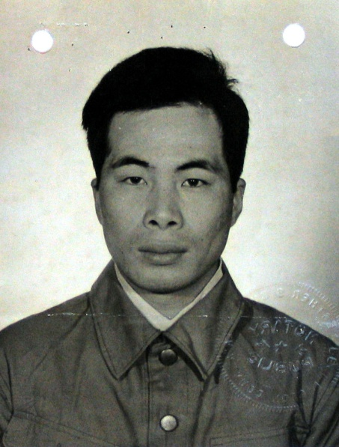
Galley Sergeant, Shuji Nakamura, sentenced to 19 years hard labor. Docket/Date: 53/ May 1 - 28, 1947

.
Supply Room, Shozo (Seizo) Nagakura. Nicknamed the Mad Corporal, or the Candy Kid, sentenced to 40 years hard labor. Docket/Date: 35/ May 10-14, 1946
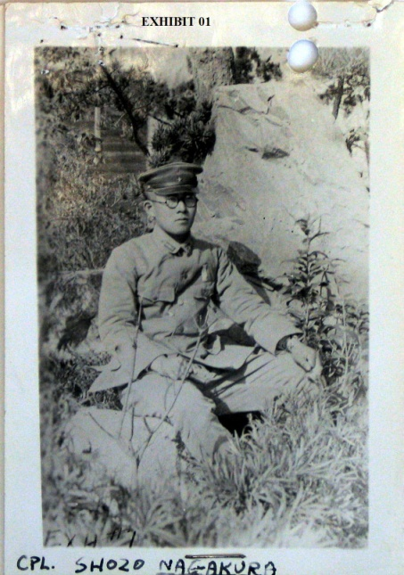

Yukio Asano, sentenced to 14 years hard labor. Interpreter. Docket/Date: 53/ May 1 - 28, 1947
