PERPETUATION OF TESTIMONY OF
ROBERT S. COOK
Formerly Cpl. Med. Detach.
ASN 17027610
1002 Goodwin Street, El Dorado, Arkansas

My name is Robert S. Cook. My permanent home address is 1002 Goodwin Street, El Dorado, Arkansas. I am now 36 years old. I was formerly a Cpl., ASN 17027610, #1 Field Hospital, Bataan, having enlisted August 13, 1941. I went overseas September 8, 1941 and returned to the states October 24, 1945. I was discharged from the Army on June 1, 1946.

I was captured on Bataan, Philippine Islands, on April 9, 1942 by a Japanese Tank Battalion, the name of which is unknown to me.

Being a Medical Corpsman I was held at No. I Hospital, Bataan, attending the sick and wounded of our forces. Later I was transferred to Camp O’Donnell, P.I., on July 6, 1942.

I was held at Hospital No. I, Bataan, P.I. until 7 July 1942; then at camp O’Donnell, P.I. until sometime in January, 1943; then at Bilibid, P.I., until about October 1943; then Cabanatuan, P.I. until March 1, 1944; then back to Bilibid until 7 March 1944; on which time I sailed to Japan and was interned in Camp No. 4 Yahata, Japan on 24 March 1944. (Kenwa Maru)

While at Cabanatuan Prison Camp No. 1 or No 2, (it is not clear to me the exact number of the camp) I saw a civilian guard commonly known as “Air Raid” beat and mistreat prisoners on 7 or 8 occasions with a hoe or pick handle which he habitually carried. When attacked by “Air Raid”, prisoners were beaten unconscious, and after returning to consciousness were forced to return to work. All of these instances of beatings were always carried out on the farm surrounding the prison camp. On one occasion I saw “Air Raid” and a two star private, commonly called Charlie Chaplin, beat with hoe handles, an American prisoner, name and rank unknown. These beatings took place between October, 1943 and March, 1944.

At Camp No. 3, near Yahata, Japan in March, 1944, I saw the Sgt. Major of the camp, name unknown, and the interpreter a civilian, name unknown, force a prisoner, who was in service with the Dutch Army, into a water vat up to his waist. As it was bitterly cold at this time of year, this was considered severe punishment. The Dutchman was forced to stay in the water approximately two hours. The Camp Commander Rickatecky (phonetic), forced all internees of this camp to walk by and witness this punishment. As I walked by I noticed the Dutchman shaking with cold and with a blue color as a result of the cold. The Dutchman was accused of stealing food from the Mess Hall. Various signs and posters were exhibited throughout the camp stating that similar punishment would be given to any prisoner stealing food or trading any article.

In March, 1944 at this same camp, I witnessed the beating of Sgt. Woodall, 131st F.A., and a civilian, name unknown, who was captured on Wake Island. Sgt. Woodall and the civilian, suffering from extreme cold, had stolen some clothing and were caught. I watched these two men being carried into empty barracks and beaten with various types of clubs by the Sgt. Major and the civilian interpreter of this camp, names unknown. A Dr. Hoddō, (phonetic) Camp Doctor at this prison was present at these beatings and administered many blows with his club. A Cpl. By the name of Nagakuri (phonetic) who was in charge of the clothing room at this camp, burned off with a cigarette the little finger nail of the hand (which hand unknown) of the civilian. I was assigned to the hospital at this prison and attended the wounds of Sgt. Woodall immediately after the beatings. He was unconscious and suffering from shock, numerous bruises over his entire body and from beri-beri.

Almost every night while interned in Camp No. 3 I saw various guards strike prisoners with clubs while at roll call known at Tenko. I do not recall the names of the two guards who freely participated in these bearings. On was called “Bull Dog” and the other “Water Snake”. Water Snake’s name was Manina (phonetic). Water Snake had the nasty practice of spitting into prisoners faces without any reason at all. No reason was ever given for any of these beatings at Tenko, except that the men were not properly at attention.

There were approximately 1,200 prisoners at this camp, including American, British, Dutch, Javanese and Chinese. Prisoners were quartered in low one story wooden buildings about 100 feet long and 18 feet wide. The buildings were always unheated except for one hour periods at night during very cold and freezing weather. Our bunks were infested with lice, bed bugs and sand flees. We were all infested with lice and various types of insects, the name of which I do not know. Despite our continuous complaints to the Camp Commander and others in charge, no effort was made to provide us with any insecticide or to improve our situation in any way.

Our clothing was not sufficient to keep us warm during the cold winters. Although there were ample supplies of Red Cross shoes in stock at this camp and also many various types of Japanese shoes, these were not issued to us. As a result we made our own shoes by cutting our foot outline on a 2 x 4 board and attaching same to our foot by means of a leather strap. Our diet consisted mainly of rice, and more rice. Very seldom did we have any fish, meat or vegetables which would have prevented the various vitamin deficiency diseases such as beri-beri and scurvy. Medication and bandages were virtually impossible to obtain from the Japanese. Most of the Red Cross packages sent to us were opened and used by the Japanese. These packages which included food, cigarettes and medical supplies, were hidden from us, and from time to time used by the Japanese. A Japanese hospital corpsman by the nickname of “Commander” told me on various occasions that they had no bandages or surgical instruments that they could spare for use on our prisoners. An American prisoner’s arm was amputated at this camp by medical officers of our own forces with a hack saw blade after he was wounded by a bomb dropped by American forces on Unwater (phonetic) Iron Works, which was located near our camp. This took place on or about 11 August 1945, and approximately 19 August 1945 we found about 32 large boxes of Red Cross Medical Supplies, including all types of surgical instruments, which had been hidden from us by the Japanese.

Robert S. Cook

STATE OF ARKANSAS )
) SS
COUNTY OF UNION )

I, Robert S. Cook, of lawful age, being duly sworn on oath, state that I have read the foregoing statement consisting of three pages, and this it is true to the best of my knowledge and belief.

Robert S. Cook

Subscribed and sworn to before me at Army & Navy General Hospital, Hot Springs, Arkansas, this 24th day of August 1946.

Joseph Robinson Lynn
Notary Public

My commission expires Dec, 16, 1947.

STATE OF ARKANSAS )
) SS
COUNTY OF UNION )

Personally appeared before me, the undersigned authority for administering oaths, one ROBERT S COOK, to me known who, after being duly sworn deposes and sayeth:

My name is Robert S Cooke and I live at 1002 Goodwin Street, Eldorado, Arkansas. I was formerly a soldier in the United States Army, serial number 17027610. I was captured by the Japanese Army Ground Forces on the 9th of April 1942. I was held in the Philippine Islands until the 7th of March, 1944 when I was sent to Fukuoka Camp #3, in Japan. I stayed there until the 15th or 16th of September 1945.
While at that camp I saw a Dutch prisoner of war badly mistreated. He was accused of stealing food from the kitchen. An interpreter by the name of Asano and a Sgt Major whose name I do not recall but whose picture I have identified stripped all the clothing off the Dutch Prisoner and made him stand in water about knee deep. He had to stand there from about 1:00 p.m until about 5:30 p.m. It was during the latter part of March and it was cold. The Dutchman turned blue from the cold. I saw him standing there myself so there was no mistake about it. I saw that Sgt Major knock the Dutchman down several times before they took the clothing off of him. And when he was taken to the guardhouse after standing out in the cold all afternoon he was beaten some more by the guards. I did not see that happen, it was told to me. He was kept in the Guardhouse for quite a while after that. He stayed at the guardhouse at night and was made to work in the steel mill in the daytime. The prisoners in that guardhouse had to sleep on a wooden floor without blankets. I know that is true because I was kept there three days and nights myself.
About the 5th of April 1944 I saw Asano and the same Sgt Major and two other guards beat Sgt Woodhall of the 131st FA and man named Cash who was a civilian off Wake Island. They took a cigarette and burned one of his fingernails off, I think it was the right fingernail, trying to make him confess to stealing some clothing. They beat both Cash and Woodhall with bamboo poles until they were unconscious. Then they were put in the guardhouse for 20 days each.
On the 11th of August 1945 Lt Commander Markwicki (spelling uncertain) Captain W N Anderson, M/Sgt George Phillips of the Medical Department and I amputated the right arm at the shoulder of a prisoner. We had to use a hacksaw blade because the Japanese medical officer in charge on that date told us they had no bone saws. When the camp was turned over to us a few days later we found thirty-two cases of Red Cross Supplies which contained medical supplies including bone saws and other surgical instruments.
Further deponent sayeth not.

Robert S. Cook

My commission expires June 10, 1947

Sworn and subscribed to before me this 29 day of January 1947.

WSI Janresson (sp)
Notary Public

Witness: Walter A Dunham, Special Agent CIC

STATE OF ARKANSAS )
) SS
COUNTY OF UNION )

Personally appeared before me, the undersigned authority for administering oaths, one Robert S Cook, to me known, who after being duly sworn deposes and sayeth that

The photograph on the reverse of this page is a photograph of a Japanese army Sgt. Major who was a party to the mistreatment of a Dutch POW as outlined in my affidavit dated 29 January 1947.

Robert S Cook

Sworn to and subscribed before me this 29 day of January 1947.

WH Jameson(sp)

My commission expires June 10, 1947.

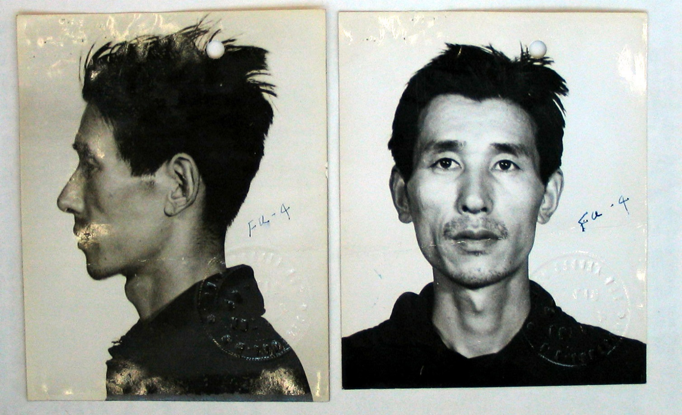

STATE OF ARKANSAS )
) SS # 196
COUNTY OF UNION )

Personally appeared before me, the under signed authority for administering oaths one Robert S Cook, to me known, who after being duly sworn deposes and sayeth that

The photograph on the reverse of this page is a photograph of a Japanese interpreter named Asano who was a party to the mistreatment of a Dutch POW as outlined in my affidavit dated 29 January 1947.

Robert S Cook

Sworn to and subscribed before me this 29 day of January 1947.

WH Jameson(sp)

My commission expires June 10, 1947.

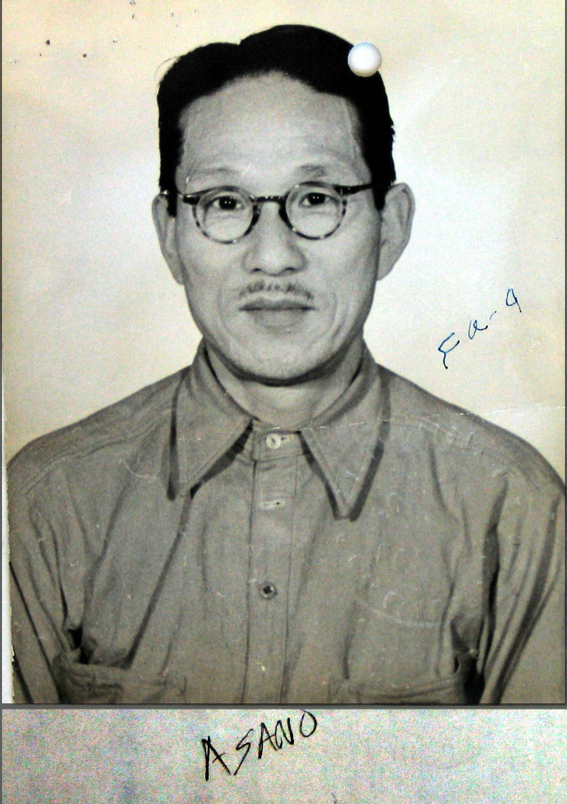

STATE OF ARKANSAS )
) SS # 479
COUNTY OF UNION )

Personally appeared before me, the under signed authority for administering oaths one Robert S Cook, to me known, who after being duly sworn deposes and sayeth that

The photograph on the reverse of this page is the photograph of a Japanese soldier I saw at Prisoner of War Fukuoka Camp #3, Japan. I am not positive but I believe he was mess sgt. [Nakamura].

Robert S Cook

Sworn to and subscribed before me this 29 day of January 1947.

WH Jameson(sp)

My commission expires June 10, 1947.

