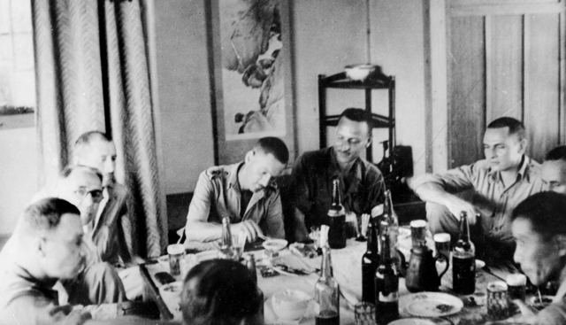
Omuta, Fukuoka Prefecture, Japan 1945-09.

The description claims: This photo was captured during a party given by Baron Mitsui for Allied Officers held in Fukuoka Camp 17. Omuta, a provincial manufacturing town on the island of Kyushu.
The caption reads, Left to right: Captain Richard Parker, Australian Army Medical Corps; Padre C. Hamel, Royal Netherlands Army; Lt. Theodore Bronk, US Army Medical Corps (USMC) – one of the camp doctors,
Scotty Howell, Australian Infantry Force; and Lt. Gerrit Bras, Royal Netherlands Army Medical Corps.
However, we do not know if this description begins with the man at the farthest left.

Baron Mitsui headed the Mitsui Corporation, owner of the mine in which most camp’s POWs were held and forced in to labor. Fukuoka Camp 17 held American, Australian, Dutch, and British POWs.

