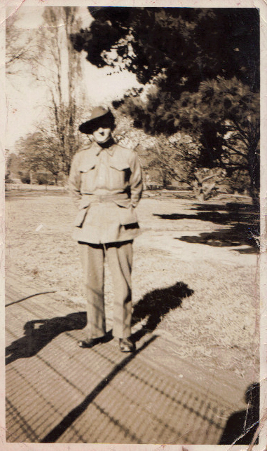
Christian William J. Watson

Australian soldier
Born on the 23/11/1905 at Ringarooma.
Enlisted on the 2/6/1941 at Launceston Tasmania.
Assigned to the 2/40th Battalion.

Grandson Nathan Watson notes, “Grandfather was from Ringarooma Tasmania.
Before the war he went with the last name Nuthall and then changed to Watson Why? We don’t really know.
He didn’t really talk about the war, so we have nothing to share.”

Photos – prewar (left); feeding his pet kangaroos (post war-lower left)
and POW reunion 1979 in Ulverstone Tasmania (Watson is center-with glasses)
