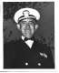
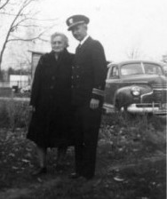
Clarence Mariet Taylor

Navy - C Boatswain / retired as Lt USN

Born: 24 Oct 1908 - Deceased 18 Jan 1970
(aged 61) / Buried in Arling Nat Cemetery

Clarence with his mother Josie after his return as a POW and (right) in uniform. Photo credits: wife, Mary Agnes Taylor
Additional photos can be viewed here: https://www.findagrave.com/memorial/49322973/clarence-mariet-taylor

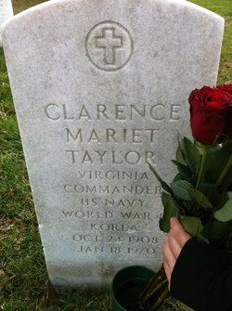
Clarence was a survivor of the Oryoku Maru sinking.
His good friend, JOSES MAURICE,CDR/MD USN died as a POW and Clarence
is credited several time with helping Maurice several times during his time as a POW and during his death.

The following pages are part of an affidavit and Clarence’s
statements of his experiences at Cabanatuan and his internment at Camp 17.

