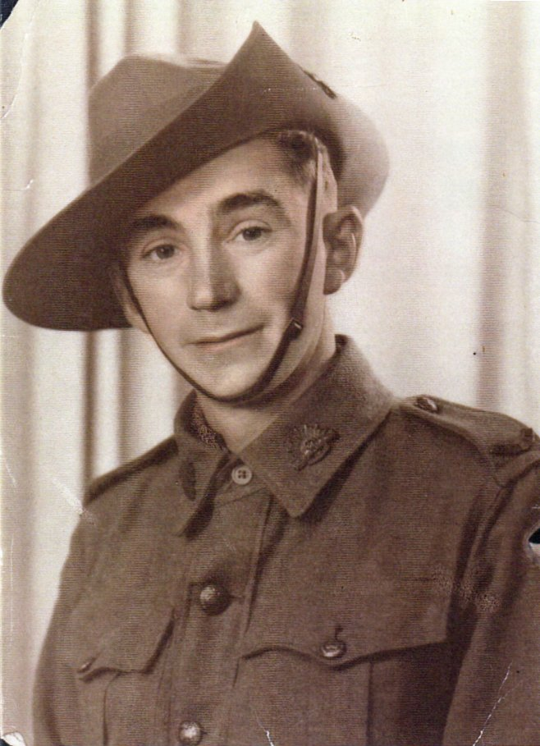
Jack Edward Shelley
Australian Army – Driver Specialist

My father was as an Australian POW. His name was Jack Edward Shelley NX66800. He was in Singapore when it fell and was in Changi and then the Thai Burma Railway and then transported to Camp 17 in Fukuoka.
Unfortunately he passed away in February 1956 due to effects of his imprisonment and left behind his wife and three children aged 8, 7 and 2.

I am also attaching a photo of a cape (see next page) that my mother had and I would like to tell you the story she told me about it and wondered if there is still any one from that camp still alive if they might recognize the cape and verify what my mother told me.
The story I was told that every day when they went down to work in the mines, there was a budda type statue which they had to bow to and the statue had this cape around it.

My mum said that he swore if he ever got out of that place that he would take that cape with him and obviously he did. I have asked some Japanese people in Australia if they could read the writing and they said it was very old but one said it was something about coal which would make sense seeing the mine was Mitsui Coal.

I would love it if anyone could confirm this story as I would like to donate it to the Australian War Memorial but want to make sure of the facts.

See Cape, next page…
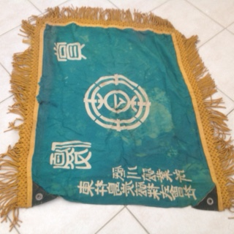

Note: While no one has been able to definitively confirm the story, I have been told of the statue in past accounts/emails for former POWs. Yet, asking other former American POWs, the answers conflict. Some definitely remember the statue, but cannot recall bowing; others say they never saw one in the mines and are adamant they never had to bow to one.

