Hezakiah Franklin Sallee
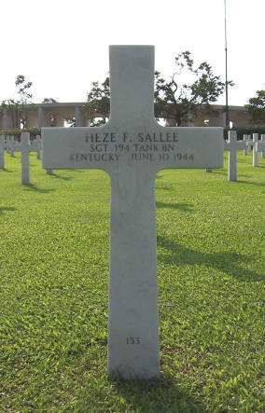
Born: 14 June, 1920 - Mercer County, Kentucky Nickname: Heze
Parents: Hez & Sally Sallee - Siblings: 4 brothers, 1 sister
Hometown: Harrodsburg
Enlisted: Kentucky National Guard
Inducted: U. S. Army - 25 November 1940
Training: Fort Knox, Kentucky, Camp Polk, Louisiana
753rd Tank Battalion 192nd Tank Battalion, Company D
Brother James was in HQ Company and his life when the Arisan Maru
was torpedoed in the South China Sea
Overseas Duty: Philippine Islands - Engagements: Battle of Bataan
Prisoner of War: 9 April 1942, Death March
POW Camps: Philippine Islands: Camp O'Donnell & Cabanatuan
Japan: Fukuoka Camp 17 - coal mining
Hell Ship: Clyde Maru - 23 July 1943 - 7 August 1943
Died in Camp 6 June 1944 - fractured skull - coal mine accident
Note: Sgt. Heze F. Sallee's grave erroneously shows him as a member of the 194th Tank Battalion. Although D company fought with the 194th, the company was never transferred to the battalion and had been returned to the command of the 192nd before the surrender. Jim Opolony
Credit: Jim Opolony: 192nd & 194th Tank Battalion

