David Runge

Australian Army
Driver, 8th Australian Division, Australian Army Service Corps
22 Brigade Company

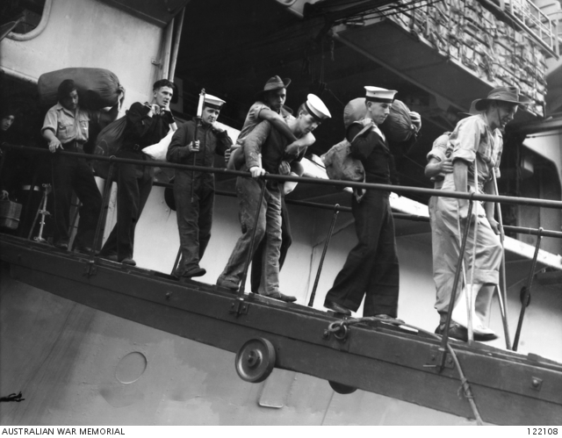
Very descriptive oral interview of David’s experiences as a prisoner of the Japanese, 1940-1945, interviewed by Margaret Evans.
Oral Interview accessed here: https://www.awm.gov.au/collection/C1006597

AWM Photo Description
Members of 1 Company, Australian Army Service Corps liberated from Prisoner of War Camp Fukuoka 17. Identified are Private John Joseph Towers on crutches and Private David Runge being carried, coming ashore from the aircraft carrier HMS Formidable at Circular Quay. Private Runge had both legs amputated after being tortured whilst a POW.
Credit: AWM & McQuillan, Ernest Mervyn.

Runge Biography Credit: Australian War Memorial - https://www.awm.gov.au/

