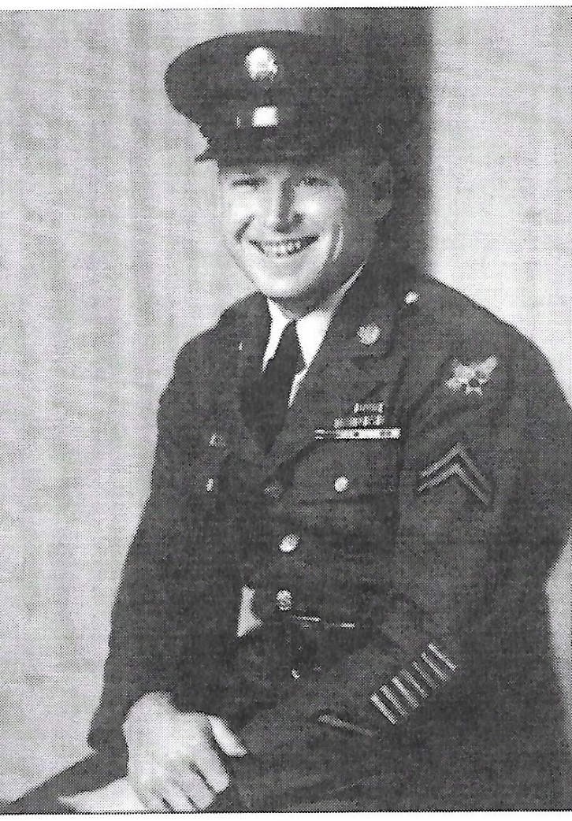
Cecil Waldo Parrott

Bellevue vet refused to die in POW ordeal: Now war against terrorism delaying his hope of justice.

This is a story of survival, of heroism and triumph and a final quest for justice.
This is Cecil Waldo Parrott's story, the story of a man who survived as other men dropped dead around him -- during the Bataan Death March, in the darkness and desperation of the Zero Ward, as a slave laborer far below ground in Imperial Japan's coal mines.
Maybe it was the friendly Japanese soldier he met along the way or the daydreams of a future love that kept him going. Maybe it was the poetry he wrote, reminding him of better days to come, or the myriad recipes he jotted down on the back of canned food labels -- recipes concocted after the coal mines had blackened his skin, but not his heart.
There may be days in a man's life when he thinks it might be better to be dead than to witness the horror all around him. Cecil Parrott has lived through such days. One thousand, two hundred and twenty-eight days.
For more than three years during World War II, Parrott was imprisoned by the Japanese -- from the time of the 55-mile Death March on Bataan in April 1942 until the end of the war in August 1945.
During the eight-day forced march in the Philippines, he lost 66 pounds. When he finally made it to Camp O'Donnell, a POW camp on Bataan, he carried just 97 pounds of skin and bone on his 5-foot-8-inch frame. Shipped to Japan in September 1944, Parrott spent a year working day and night in the coal mines of the southern Japanese cities of Omuta and Fukuoka. He is one of an estimated 5,000 to 6,000 men still living who worked there -- for nothing. Not a dime.

It was war. As they die off, men who were imprisoned by the Japanese during World War II, those who suffered unspeakable horrors during the death march, in the POW camps and coal mines, are going to their graves feeling slighted, says Parrott, now 81.

While many Americans have embraced a new kind of war in response to the terrorist attacks of Sept. 11, some veterans from an old war are still fighting. "I went to Boise, the county seat, and signed up for the Army. And the reason I chose the Philippines was because my older brother used to pal around with a guy who was in the service before that. And he'd been in the Philippines. And he talked as if it was a glorious place to be.'' -- Cecil W. Parrott, on his decision to join the Army in November 1940, a year before the Japanese bombed Pearl Harbor.
This month is the 50th anniversary of the formal peace treaty signed in San Francisco between the United States and Japan. According to Japan and the U.S. State Department, one provision of the treaty banned claims by Americans used as slave laborers.

Parrott and the men who served alongside him have been fighting to get compensation for the horrors they lived through. Bills in Congress seek to pay the men, but now any action has been pushed back by the focus on the terrorist attacks.

Parrott is also part of a class-action lawsuit filed in California in 1999 and now headed for the 9th U.S. Circuit Court of Appeals seeking damages against present-day Japanese corporate behemoths Mitsui and Mitsubishi, owners of the mining companies Parrott and about 20,000 other POWs worked for during the war. Ex-POWs such as Parrott want what they say is their fair share. In the other major theater of World War II, a $5 billion settlement last year was divided between nearly a million survivors who had worked as slave laborers for German companies during the war.
A Bellevue resident since 1956, Cecil Parrott is a gentle soul. He is thoughtful and reflective, and he does not seem bitter about his experience. He's not some old war bird seeking revenge. He doesn't talk much about the war, unless you ask. Then, from behind bespectacled, clear blue eyes, he tells you plenty.

``I think it's due to us, I really do,'' Parrott says. ``We worked as slaves for the Japanese. I don't know how much money they made back in that time, but they made money off of us.'' "If you had a ring that was so tight on your finger, because your finger had swelled up some, they would cut your finger off. That's how cruel they were.'' -- Parrott, on the treatment of Americans by Japanese soldiers during the Bataan Death March.

Born in Mount Vernon, in the Skagit Valley, on July 20, 1920, Parrott spent his boyhood moving from town to town in Idaho, following a father who looked for work as a carpenter during the Great Depression.

Before joining the Army in 1940, Parrott met a girl named Ruby at a vocational school in Weiser, Idaho. They married in 1947, after the war, and 54 years later they are still married and living in the Lake Hills area. Unable to have children of their own, the couple adopted identical twin girls in 1955, Mary Ann and Cheryl Lee. But before all the good years of home and family, Parrott went through hell.

In November 1940, he found himself in the tropical wonderland of the Philippines. It would be more than a year before the Japanese attacked Pearl Harbor, and for Parrott, a private first class in the Army Signal Corps, the future was bright and the nights were warm. Peacetime was easy, serving just four hours a day.

On Christmas Day 1941 Parrot was sent to Corregidor and assigned to the Medical Corps, as manila was declared an open city. Shortly after that his Signal Corp outfit was sent to Bataan. Within a few days Parrott hitched a ride on an ammunitions barge across manila bay to Bataan. Mr. Parrott joined his outfit as a standby radio operator.
The Japanese attack on Pearl Harbor changed all of that. America was at war, and in early April 1942 the Japanese captured Bataan on Manila Bay. Parrott and 70,000 other American and Filipino soldiers found themselves walking 55 miles from the tip of the Bataan Peninsula inland to Camp O'Donnell.

Starved and mistreated, kicked, beaten and stabbed along the way, only 54,000 made it to the camp. Almost 10,000 died; the rest escaped into the jungle.

Parrott believes that if not for one compassionate Japanese soldier who he and five other marchers encountered along the way, he would not have made it. After five or six days of marching, they had fallen off from the main pack, Parrott says. Up ahead, the soldier waved in a friendly, come-here way.

``By the time he waved at us, I was on my last legs and I couldn't keep up,'' Parrott said. The Japanese soldier said in English: `You, come here, come here,'' Parrott recalls. The men walked over, their legs buckling underneath them. `You hungry?'' the Japanese soldier asked. His own troops off on maneuvers, the soldier offered the men some leftover food -- one mackerel, cut into five pieces, some rice and some sweet tea. He told the men he was a cook, that he had been brought in as part of Japanese reinforcements. He said he had no hatred toward Americans.`I probably weighed about 80 pounds. When I was down there, somebody would be dead next to me every morning I woke up. I decided I wasn't going to die like the rest of them. There was no way I was going to go to Boot Hill.'' -- Parrott, recalling Zero Ward at a POW camp in Cabanatuan City.

At Camp O'Donnell, the POWs were slowly starving to death. The men ate whatever they could find. If a stray dog or cat came into the camp, the men would catch the animal if they could and skin it, cook it and eat it. Parrott even ate cobra meat one time when a Japanese guard stabbed the snake, yanked its fangs out and barbecued it for the POWs.
The regular diet consisted of a watery rice stew for lunch and rice with maggots and vegetable tops for dinner.
Parrott was later moved to another POW camp, Camp No. 1 in Cabanatuan City. There, Parrott came down with dysentery and beriberi. One day, he was hauled to Zero Ward, an area under the camp's barracks that held other men too sick to function. They were given no food and no water -- just left to quietly stop breathing.`I was put down there to die,'' Parrott says. ``I had no treatment of any kind.''

It was a dreadful pit of a place filled with emaciated bodies and broken spirits. Parrott saw that the men there had lost their will to live. They talked about how their families had abandoned them, how they did not receive any mail from them. But Parrott knew none of the men got mail -- the Japanese didn't allow it. Parrott also knew the Zero Ward inmates were losing touch with reality as their bodies withered.

Parrott, however, refused to die. He was too young to die, he told himself; he had too much to live for. He did not want to be buried at Boot Hill, the makeshift cemetery at the camp where each grave held 15 to 20 bodies. After 10 days in Zero Ward, the Japanese guards gave up on his dying and took him back up out of the death chamber.
He credits his desire to live, his desire to one day eat rich, healthy meals, to drive a new car, to fall in love, to hug family and friends, for keeping him alive.

Back home in Idaho, Parrott's parents, John and Clara, had no idea what had happened to him after Japan captured Bataan. They received a telegram saying their son was among the dead and missing, along with another young soldier from Weiser. It was not until 1943, a year after the march, that the couple received word their son was a POW.
Later, Parrott was allowed to send a 45-word telegram to his mother: ``Please know that I am well. Am informing everyone of my health. Hope that brothers and sisters are in good health. Give regards to all friends. Pass my love to all relatives. Divine love to you and Dad. Your son, Cecil W. Parrott.''

Although he wasn't the only POW to emerge alive from the Philippines, Parrott's survival is nothing short of a miracle, say those who know of the horrors. POWs came home with stories of being beaten and tortured and witnessing public executions in which their comrades were blindfolded and decapitated.

``Camp O'Donnell was, for many, the most horrific experience of the war,'' writes Hampton Sides in his current best-selling book, ``Ghost Soldiers,'' published this year. `It was the place where all the seeds of hunger and disease sown on Bataan came to full fruition. Americans had not seen derivational grotesqueries on such a vast scale since the days of Andersonville, the infamous Civil War death camp for Union soldiers in Georgia. One prisoner later wrote, `Hell is only a state of mind: O'Donnell was a place.''

Twenty-seven percent of Japanese captives died during the war, compared to 4 percent of Allied POWs held in German and Italian camps, according to Sides' book.

In September 1944, Parrott was put on one of the infamous Hell Ships, so named because of their horrendous living conditions, and taken to Japan.”That was one of the worst beatings I ever got. In fact, we called him The Maniac because he was a known killer. He beat one guy, actually broke his back with a 2 by 4.'' -- Parrott, describing a Japanese guard who beat him after a day in the coal mines.

At Camp 17 in Omuta, Parrott and other POWs mined coal for Mitsui Mining. Later he was taken to another city, Fukuoka, for more dangerous and exhausting work. One day a large timber fell on his ankle, nearly mangling it. He walked club-footed for a while, but the ankle eventually healed itself.

On another day, he was bloodied by a Japanese guard. The man accused Parrott -- who then weighed all of 125 pounds -- of not saluting him, and he beat Parrott to a pulp.

After three years of being around Japanese soldiers and guards, Parrott learned to speak the language and is still fluent today. Prisoners had to learn to count in Japanese because the guards would call out their numbers and if they didn't respond they were beaten over the head with a stick.

At night, he and other POWs wrote poetry and recipes -- filled with eggs and butter and ``nothin' but good stuff'' -- on the backs of canned-food labels. Anything to keep them going.

On Aug. 6, 1945, the United States dropped an atomic bomb on Hiroshima, killing about 135,000 civilians. On Aug. 9, another bomb hit Nagasaki, killing about 70,000. Japan surrendered a few days later, and the war was over. But Parrott and other POWs in Fukuoka, situated between Hiroshima and Nagasaki in southern Japan, did not know it.
They were told American planes were in the area on reconnaissance missions, not to drop bombs. It wasn't until Aug. 19, four days after Japan surrendered, that American troops showed up to release and feed the POWs.

After 41 months as a prisoner of war, and after serving in the early occupation forces, Parrott was flown back to Manila to s rest camp for RAMPS (Repatriated American Military Personnel).

Next Mr. Parrott arrived in November of 1945 at the Veteran's General Military Hospital in San Francisco.
He then was sent to Madigan Military Hospital in Fort Lewis for more thorough medical treatment and necessary dental treatment.

Finally, Parrott was home, checking in and out of Fort Lewis, receiving hugs from family and friends.
But he never got to see his father again. John Henry Parrott, 63, died in a Weiser hospital from a lengthy illness shortly before his son's rescue.

``I know back in 1951, when they met in San Francisco, they had no idea how we were treated. I think it was stupid of the State Department, at that time, to make the decision that they did against us, without even knowing anything about it.'' -- Parrott, on the peace treaty that barred any claims by Americans.

For years after the war, Parrott went on with his life, trying to bury the memories and the horrors he lived through. After graduating from Oregon State University in 1952, he worked 18 years as a Boeing engineer. Then one day a couple of years ago, he got a call from Lester Tenney, a former POW and retired Arizona State University history professor, who was suing Mitsui and Mitsubishi. Suddenly Parrott was part of a class-action lawsuit.
And he got to thinking, “Our government stood behind the guys that were fighting Germany, and they allowed their claim to go through. I don't understand why they don't let our claim go through,'' Parrott says. Regardless of what the peace treaty between the two countries says, Parrott contends he and his fellow POWs are getting a raw deal.
In recent years, the State Department has testified in cases against Mitsui and Mitsubishi, saying terms of the peace treaty with Japan should be upheld.
Parrott has no ill feelings toward the Japanese; much of the reason is the friendly soldier who may have saved his life during the death march.

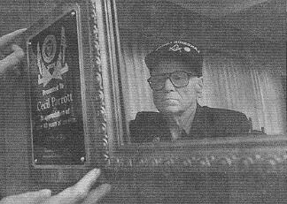
In 1981, he returned to Japan for the first time and tried to find the camps where he had lived, but they were gone. Only a smokestack remained at one. He returned again last year to Japan and stayed with the parents of a Japanese woman he met a few years ago at Newport Hills Community Church. Coincidentally, the woman's grandfather, an engineer, designed part of a coal mine where Parrott labored during the war.

But such friendships don't change his feelings about the war, and Parrott said he wants justice before he dies.

“I really think the American people should not forget what these brave men went through.''

by Mark D. Baker, Bellevue Journal Reporter 2001-09-30

Cecil Parrott, Death March survivor, dies

He survived the infamous Bataan Death March, and endured savage beatings, bouts of dysentery and starvation as a Japanese POW in World War II.
But Cecil Waldo Parrott lost his final battle.
The Bellevue resident did not live to win reparations for himself and thousands of other POWs forced to work without compensation for Japanese companies. Parrott died Thursday at the Veterans Administration Hospital in Seattle. He was 83.
Though he endured 1,228 days in captivity, as one of 70,000 U.S. and Filipino soldiers who surrendered to the Japanese on April 9, 1942, Parrott maintained his faith in family and refused to hate his captors. He was a gentle man who “loved the Japanese people,'' said his son-in-law David Andress of North Bend. “He was very forgiving of the Japanese people, because he knew it wasn't the people (who caused the suffering), it was the military.''
Born in Mount Vernon on July 20, 1920, Parrott spent his boyhood moving from town to town in Idaho as his carpenter father sought work during the Great Depression. He met his future wife, Ruby, at a vocational school in Weiser, Idaho. They would marry in 1947, after the war ended.
Parrott enlisted in 1940, and spent more than a year stationed in the Philippines before the Japanese bombed Pearl Harbor. He was a corporal in the U.S. Army Signal Corps when the Japanese captured the Bataan peninsula. More than 10,000 soldiers would not survive the resulting Death March, victims of exhaustion, thirst, disease and horrific treatment by their captors.
“If you had a ring that was so tight on your finger, because your finger had swelled up some, they would cut your finger off. That's how cruel they were,'' Parrott told the Journal in an interview in 2001. “I saw men bayoneted for trying to get a drink. I decided that dying of thirst was preferable,'' he said.
He credits a cook from the Japanese army with helping him survive and enabling him to see the enemy as individuals. He and other stragglers were stopped by the cook, who shared what little he had ----some boiled rice, sweet tea and one mackerel, cut into five pieces. The tea, the only clean water he had during the march, probably saved his life, Parrott told the Journal.
Surviving the nearly 70-mile march was no guarantee of surviving the war. By late 1942, in Camp O'Donnell in Luzon, dysentery, beriberi and starvation had carved 68 pounds from his 165-pound frame. He was sent to “Zero Ward,'' a crawl space under the barracks where men were left to die.
Every morning, Parrott would wake up with yet another dead man next to him.
“I noticed that the night before a guy died, he would talk about how abandoned he felt, how he was convinced no one cared, that his family had forgotten him, ''Parrott told the Journal in May 1995. “Not me. I would get home to my family.'' Parrott simply refused to give up. He weighed 96 pounds when he was liberated from a Japanese work camp on Aug. 19, 1945.
Parrott moved to Bellevue in 1955 and worked as an engineer for Boeing until the layoffs of the early 1970s, son-in-law Andress said. Then he opened his own general contracting business before retiring a decade ago. He was known for helping veterans and for putting in grab-bars for seniors for a minimal charge, just to help out, Andress said. “He was a giving person,'' Andress said.
The war brought Parrott a Purple Heart, Bronze Star and other medals, but left him with nightmares and digestive problems throughout his life, Andress said. He testified against some of the prison guards after the war, “but he was able to separate individual Japanese people,'' Andress said.
“We should never forget the sacrifices Americans have made in war,'' Parrott told the Journal in 1995. “But we also should remember the point of it all: peace and brotherhood among all peoples.''
In 1999, Parrott joined a class-action lawsuit filed in California seeking damages against present-day Japanese corporations Mitsui and Mitsubishi, owners of the mining companies that used the labor of 20,000 POWs during the war. They have not been compensated to this day. “What's sad,'' Andress said, “is at the end he was very upset'' about that.
Parrott is survived by his wife of 56 years, Ruby of Bellevue; daughters Cheryl (and David) Andress of North Bend and Marcy (and Tim) Davis of Yakima; and five grandchildren.
For further detailed accounts and information on Cecil, visit http://mansell.com/pow_resources/camplists/fukuoka/fuk_01_fukuoka/fukuoka_01/CWPartcl.htm

