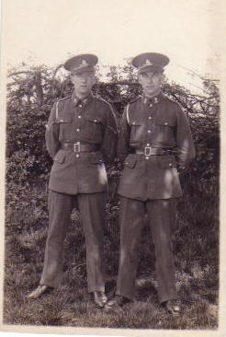
Kenneth G. Norman
Ken was born in Harlesden, London on 9th February 1920. The family moved to Letchworth, Hertfordshire in the early 1930s.
On leaving Westbury School, Letchworth, Ken was employed by the Co-op and then by Prudential Insurance. He was a champion hurdler for Hertfordshire and a member of Letchworth Co-Op Football Team. He joined the Territorial Army in 1939.
Ken became a Bombardier (923493) in the 135th Field Regiment of the Royal Artillery.
He was posted to Malaya via South Africa and was taken Prisoner of War by the Japanese during the Fall of Singapore in 1942. He was imprisoned in Changi jail. From Singapore, he was taken to Thailand where he worked on the building of the Burma-Siam railway being taken to various prison camps including Bampong and Kanburi until the completion of the railway in 1944.
Ken was a prisoner on the hellship Hofuku Maru (which was known as a Kawasaki Stock Boat or steamer of with a gross tonnage of 5738 tones and 385ft long and 55 ft beam) which was to have taken him to Japan via Formosa. The vessel was bombed by the US aircraft carrier, USS Yorktown and Ken was one of the 200 prisoners, out of 1200, who survived. During this ordeal, he lost his good friend Jack Leach, drowned on the Hofuku Maru.
Photo above -Ken on the left and Jack on the right.
He spent a long time in the water before being picked up and taken to Manila. POWs were boarded onto the Hakusen Maru on 1st October 1944 in Manila Harbour and held in the hold until 3rd October 1944 when she departed. She was torpedoed by American submarines and on 11th October sailed into Hong Kong harbour. She remained in Hong Kong harbour until 21st October where she survived more allied air attacks. She then went on to Formosa where she arrived on 9th November 1944. Ken was taken to the Shirakawa Camp No 4. On 9th January 1945 he left Formosa on the hellship Melbourne Maru which arrived in Kyushu, Japan on 2th January 1945. Ken was transferred to the Omuta Camp 17 in Fukuoka, Japan on 11th February 1945 Here he was put to work in the Mitsui coalmine until he was recovered by the Royal Marines and US Marines upon the surrender of Japan in September 1945.
His days as a Japanese POW ended on 15-16 September 1945 when he departed from Nagasaki Harbour. Like most his compatriots, Ken was suffering from severe malnutrition and Beri Beri at the time of his recovery. He was one of 1000 POWs picked up and taken San Francisco by the hospital ship USS Haven from Nagasaki Harbour via Honolulu and returned to England on the Queen Mary arriving in Southampton on 18th Nov 1945.
Upon his return home he became fireman in Letchworth and then a mobile greengrocer before opening his first grocer/sub Post Office in Pixmore Avenue, Letchworth. Ken married Doris Wheatley in Letchworth on 1st March 1947 and their only daughter, Wendy, was born in Hitchin in 1958.
In 1966 Ken, Doris and Wendy moved to Guilden Morden Post Office and shop (Cambridgeshire) where the family lived until Ken's retirement in 1985 when they returned to live in Letchworth. Ken was very much involved in voluntary work for the Letchworth branch of the Citizens' Advice Bureau he was also a voluntary driver for Lister Hospital, Stevenage.
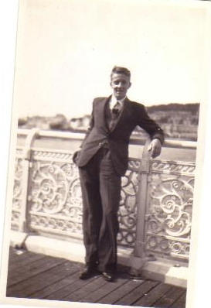
Ken spoke little of his experiences during his three and a half year captivity except to list the countries he had 'visited' and to say that he had pawned his gold signet ring in return for a bowl of rice.
According to surviving colleagues, it was Ken's sense of humor, even in the blackest times, that helped to keep him and others going throughout their three and a half year imprisonment.
Kenneth having survived the ordeal of being a Japanese POW, died prematurely in 1993 of pancreatic cancer which, the War Pensions tribunal confirmed, was due to the privations suffered at the hands of the Japanese.
NOTE: It was a very sad time indeed when in late 1993 he was diagnosed with Pancreatic cancer and died shortly afterwards on 1st November 1993. According to Mum, he had been in pain for a while but, true to form, never mentioned anything to her or me until it became too much to bear. After his death, my Mum applied for a war widows pension for which she was turned down. She and I appealed the decision and went to a tribunal in London where it was agreed that Ken had died prematurely due to the privations suffered during his time as a POW. Dad would have been delighted that Mum received a small lump sum and a monthly pension. She died in June 2002.
Photo; Ken in 1946 Submitted by Wendy Slocum, Daughter of Norman

