**Charles Iskra**

**200th Coastal Artillery – Battery “C”**

#### PRE-WAR

The photos below depict Charles and the 200th Coast Artillery (Anti-Aircraft) a short time after they were called to active duty in the spring and summer of 1941. The 200th was made up of New Mexico National Guard units that were originally the 110th and 111th Cavalry. Each battery was made up of a local guard unit which means that Batteries A, & B were from Albuquerque, Battery C from Santa Fe, Battery D from Gallup and the NW quarter of the state, Headquarters Battalion from the SE corner of the State, and so on. Once the unit was trained at Ft. Bliss, Texas, they went on maneuvers across New Mexico to show off the unit.

 As soon as the maneuvers were finished the 200th was sent to the Philippines where they were stationed on the island of Luzon at Ft. Stotsenberg near Clark Airfield to provide anti-aircraft support. The anti-aircraft gun shown was the same gun (and crew), which fired the opening shots of the war at attacking Japanese aircraft at approximately 12:30 pm on December 8, 1941. The 200th would claim 5 planes that day and a total of 85 by the end of the battle for Bataan.

Except for the one photo showing Charles Iskra and another member of the 200th on the parade ground at Ft Stotsenberg, PI all photos taken by Iskra during the battle for Bataan were lost following the army’s surrender to the Japanese on April 9th, 1942.   
  
*Contact Linda Dahl Weeks for the remainder of the photos: lvbataan@gmail.com*

|  |  |  |
| --- | --- | --- |
| http://www.lindavdahl.com/Bio%20Pages/C.Iskra/Iskra.O%20Photos/C_Iskra_with_Bar_th.jpg Charles Iskra at Ft. Bliss | http://www.lindavdahl.com/Bio%20Pages/C.Iskra/Iskra.O%20Photos/C_Iskra_at_Ft_Bliss_th.jpg  Charles Iskra with BAR | http://www.lindavdahl.com/Bio%20Pages/C.Iskra/Iskra.O%20Photos/C_Iskra_first_day_th.jpg Charles Iskra first day |

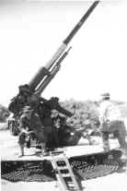

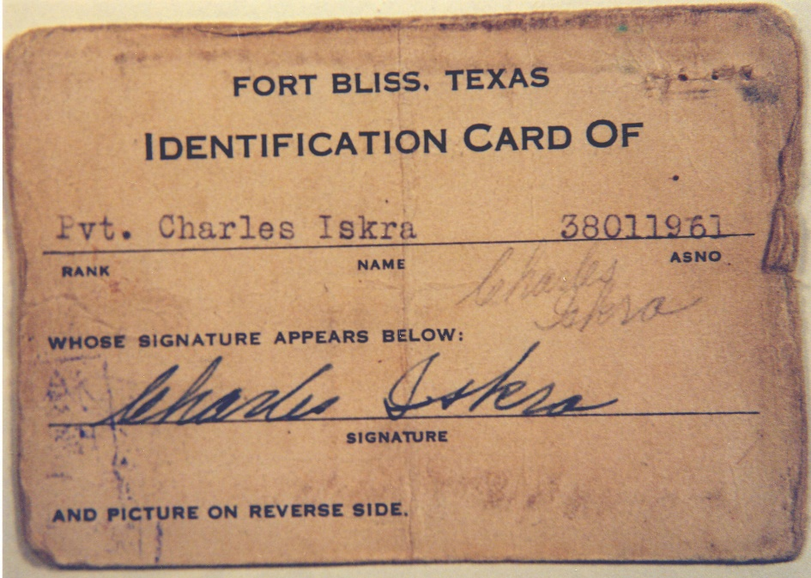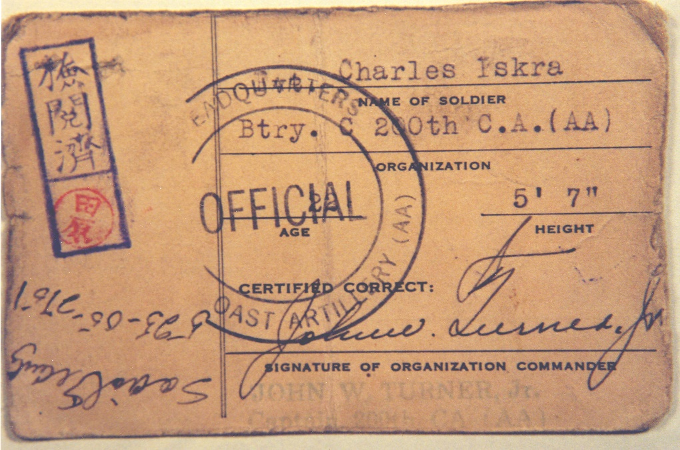

Charles Iskra's ID cards (above) and POW card sent home. (below)  
Note: as with all POW cards, often they were not authored by the POW and when   
they were, the POW's were told what to write.

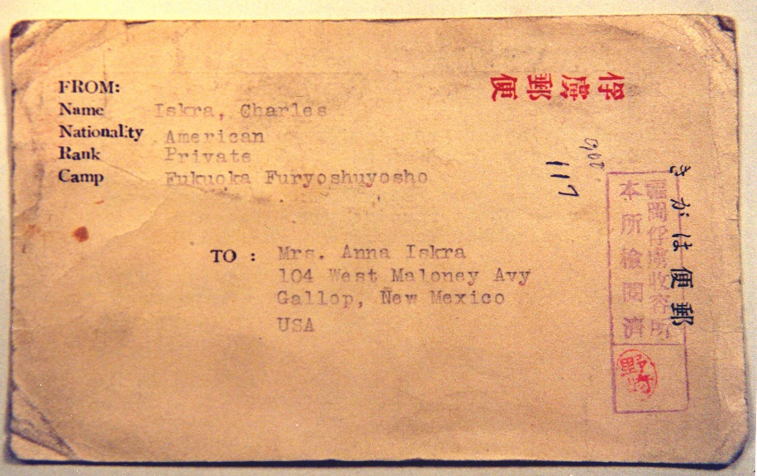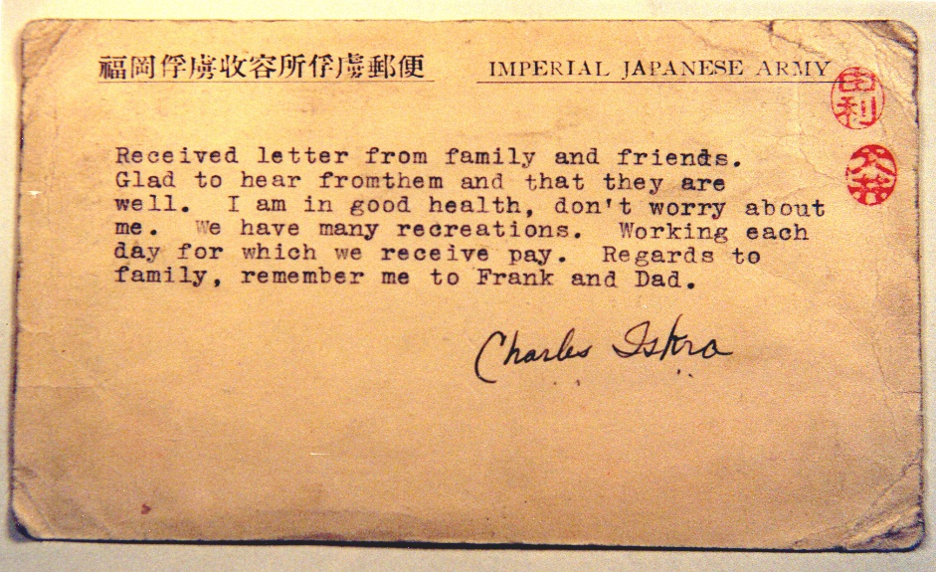

**WAR & POST WAR**

Charles Iskra was a Fukuoka Camp 17 POW. Many of the men Charles knew did not make it home. Very few of the deaths of the 200th resulted from combat. This was the case for most of the US armed forces engaged in the battle for Bataan. Battery “C” along with the rest of the 200th formed the final combat line against the Japanese when they were surrendered at Cabcaben Airfield near the tip of Bataan on April 9, 1942. They then suffered the first post surrender casualties of the battle with the execution of Captain Thwaits on April 9th, and the death of the first POW at Prison Camp O’Donnell with the execution of Charleston Miller just after arrival there. Most of the deaths of POWs from the 200th occurred at prison camps O’Donnell and Cabanatuan due primarily to disease and malnutrition, as well as deaths on the prison ships Arisan and Shinyo, which were sunk by American torpedoes. (The Japanese did not mark POW ships as holding prisoners)

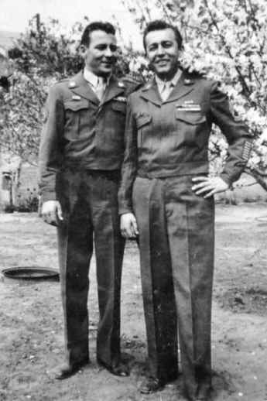

In 1943 when the war was beginning to go badly for the Japanese, the majority of the POWs were sent to Japan, and Manchuria to work in various capacities as slave labor, replacements for Japanese labor. Charles Iskra (Bango/Ban # 392) was among the first 500 POWs sent to Fukuoka Camp 17, which was operated by the Mitsui Corporation. There, along with many other Americans, Charles dug coal for the remainder of WWII.

Charles and Luis Senna (also from the 200th) were the last Americans to leave Camp 17. As a result of the mistreatment the 200th suffered as prisoners of the Japanese, New Mexico became the state with the highest per capita death rate in WWII.

Photo left is post war: RufusWhitman (Battery D) and Charles Iskra

show the seven overseas bars awarded only to POW’s following the war.

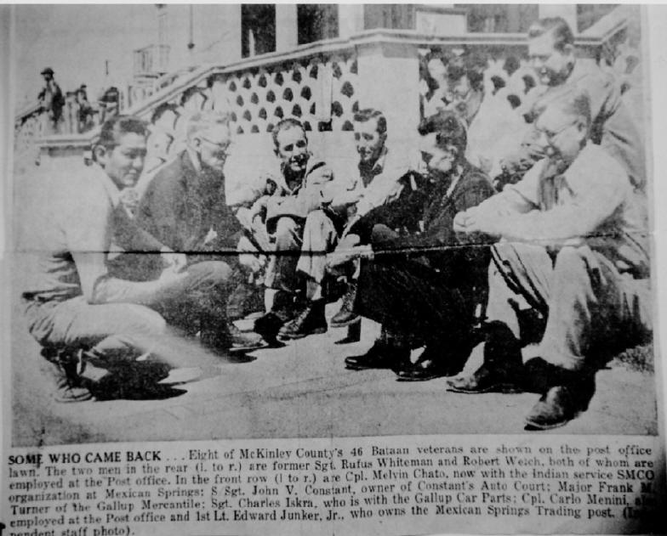

**Article from Charles Iskra's home town newspaper.  
Charles is seated in the middle, fourth man (left to right).**