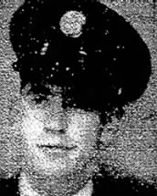
Donald Heleman
131st FA

Donald Heleman, ASN 20813982, arrived at POW Camp Fukuoka 2 Koyagi-Shima Nagasaki on the Kamakura Maru on December 7th 1942.
He was first captured and imprisoned in Java and arrived at Nagasaki via Singapore.
After 2 years of forced labor at the Koyagi Kawanami Shipyard he was transferred to Fukuoka 1 Mushiroda (Hakozaki) camp.

In 1945 he was transferred again to Fukuoka 17B where he died of acute enteritis and beri-beri on August 12th.

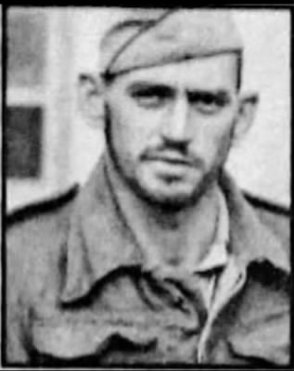
LATEST REPORT DATE: August 12, 1945;
STATUS: Died as Prisoner of War, Not Above Cases;
DETAINING CAMP: Fukuoka POW Camp #1 - Kashii (Pine Tree Camp) Kyushu Island 33-130;

Taken prisoner while serving with Battery E, 131st Field Artillery (The Lost Battalion), on Java in March 1942. He died two months before the camp was liberated.

Joined the National Guard in 1939 and was mobilized with the 36th Division in November 1940. Two of his brothers, Willie and Joseph, were killed in a motorcycle accident in March 1945, while on home on leave from the service.

Credit: Fold# Ancestry: members: donhillphoto & xm23051989210. Thank you!
https://www.fold3.com/page/85352876-donald-heleman/stories

