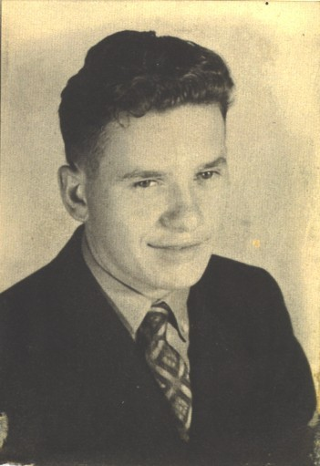

**Albert Joseph DuBois**

Pvt. Albert J. DuBois was born on January 16, 1918 in St. Paul, Minnesota to Peter and Philamoine DuBois. While a child, Albert's father passed away. His mother would remarry and the family would move to Wisconsin, where he would grow up in Webster, Wisconsin.

Albert was drafted into the army on April 9, 1941. He was sent to Ft. Knox, Kentucky and was assigned to A Company, 192nd Tank Battalion; A Company which had originated as a Wisconsin National Guard company and the army was attempting to fill vacancies created in each of the letter companies with men from the home states of the companies. In his opinion, he did not learn much at Ft. Knox since he was not there very long. The one thing that he did learn at Ft. Knox was how to drive a tank. Albert took part in the Louisiana maneuvers in the late summer of 1941. Being a tank driver, he was assigned to the tank crew of Sgt. Owen Sandmire. Albert believed that the maneuvers taught him how his tank operated in combat situations. After the completion of the maneuvers, the battalion was sent to Camp Polk. It was there that they learned that they were being sent to overseas duty.

Albert and the rest of the battalion traveled by train to San Francisco and then took a ferry to Angel Island in San Francisco Bay. There, they were inoculated and then boarded ships for the Philippine Islands.

In the Philippines, Albert's battalion was housed in tents between Clark Field and Fort Stotsenburg. On December 8, 1941, Albert lived through the Japanese bombing of Clark Field. He would next be sent out to engage the Japanese after they landed troops on Luzon. He took part in many of the engagements involving A Company. This included the Battle of Toul Pocket which wiped out Japanese troops who had been landed behind the main battle lines.

On April 9, 1942, Albert and the other tank crews of A Company were ordered to destroy their equipment. They had been surrendered to the Japanese. The members of A Company made their way to Mariveles at the southern tip of Bataan. It was from there that Albert began what would become known as the Bataan Death March.

On the march, Albert witnessed numerous beatings. He also saw the Japanese guards bayonet those who could not keep up or had fallen to the ground. In his opinion, the extremely hot temperatures, lack of water, lack of food and general fatigue of the prisoners all contributed to making the march so terrible. He recalled that all he had to eat on the entire march was one bowl of food.

As a Prisoner of War, Albert was held first at Camp O'Donnell. The worst thing about the camp was the burial detail. On an average day, fifty American prisoners had to be buried.

When Cabanatuan was opened, Albert was sent there. In this camp, he worked in the garden that grew badly needed food for the POWs. The worst thing that Albert witnessed as a prisoner there was four prisoners were forced to dig their own graves and shot. They had been caught trying to escape by the Japanese

Sometime around June, 1943, Albert was sent to Bilibid Prison for processing. There he was given a physical and was declared to be healthy. He was boarded onto the Clyde Maru. The ship sailed on July 23, 1943 and at Moji, Japan on August 7, 1943.

In Japan, he was assigned to Fukuoka Camp #17. The prisoners in this camp worked in a coal mine. Albert and the other POWs never learned that the war had ended. One day, about three weeks after the war had ended, an American B-29 flew over the camp and dropped 55 gallon drums of supplies to them. The first Americans to make contact with the former prisoners did not appear until one month after the war.

Albert was sent back to the Philippines until it was determined that he was healthy enough to return to the United States. Like many members of the 192nd, Albert was promoted to Staff Sergeant after being liberated. He returned home on Thanksgiving Day, 1945. It was exactly four years after he had arrived in the Philippines.

Before his death, Albert was the last surviving member of A Company.

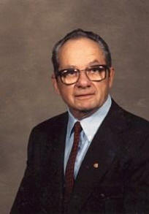**In Memory of Albert Joseph DuBois - January 16, 1918 - August 3, 2012**

Albert DuBois, 94, of Webb Lake, WI, died on Friday, August 3, 2012 at the Benedictine Living Community of Spooner. Albert Joseph DuBois was born on January 16, 1918 to Peter B. and Philemina (Duchene) DuBois in St. Paul, MN. He was baptized the 10th day of February 1918 as a Roman Catholic. He attended grade school in St. Paul, MN and moved to Scott Township when he was 14. He worked on the Durand farm becoming an honorary member of the family and served in the Conservation Corp before going into the armed services.   
  
He served 4 years in the US Army and spent 3 ½ years in Japan as a prisoner working in a coal mine. He was honored in Wausau as being the last survivor in his 192nd Company of the Bataan Death March.

He was decorated with the American Defense Service Ribbon with Bronze Star, Victory Medal, American Theater Ribbon, Asiatic Pacific Theater Ribbon with Bronze Star, Philippines Defense Ribbon with Bronze Star, 8 Overseas Service Bars, Service Stripe, Army of Occupation Medal and Japan Good Conduct Medal, District Unit Badge, 1st & 2nd Bronze Oak Leaf Cluster and Combat Infantryman Badge. He was able to see the plumes from the atomic bomb when it exploded in Nagasaki, Japan. He was saved by that bomb and Harry Truman.

He worked for the St. Paul U.S. Postal service for over 20 years, retiring in 1978.  
  
Albert is survived by his wife, Dorothy; sons, Ronald and Mike; daughter, Diana, grandchildren and great grandchildren; 8 step children; step grandchildren and step great grandchildren and nieces and nephews. He was preceded in death by his lst wife, Susan; 5 sisters and 3 brothers.

Interment will take place in the A & H Cemetery.