Harvey Lee Deatherage

Civilian

Birth -15 Sep 1902 - Saint Louis, St. Louis City, Missouri, USA

Death - 13 Feb 1945 (aged 42) Fukuoka Camp 17, Japan

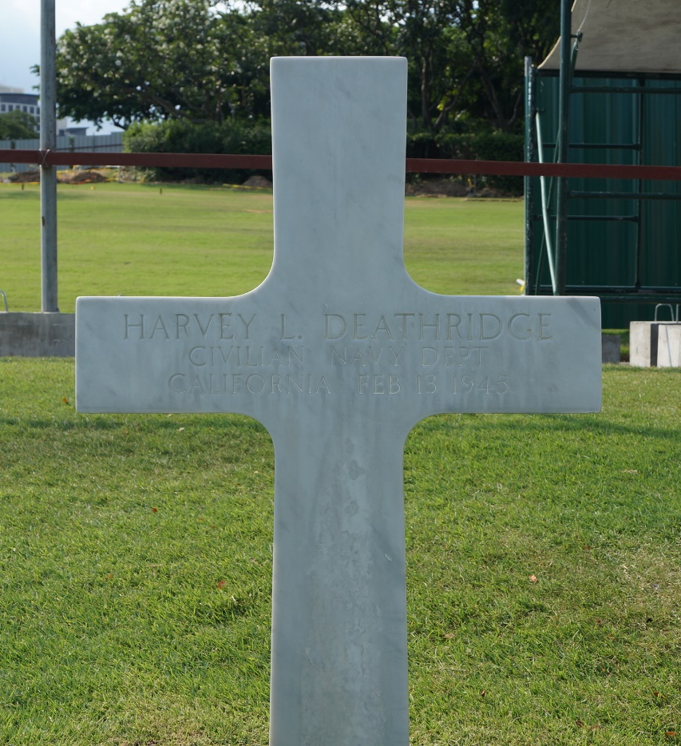
Burial - Manila American Cemetery and Memorial
Manila, Capital District, National Capital Region, Philippines

Plot - E Row 1 Grave 57

Memorial ID - 56755102

Harvey was interned at Camp Cabanatuan, then slave labored at
Las Pinas POW cxamp. He was sent to Japan, surviving three hellship bombings, beginning with the Oryoku Maru.

When he arrived in Fukuoka, at Camp 17, on 30 Jan 1945, Harvey was forced to labor in the mines. He did not last long, dying just weeks after his arrival on 13 Feb 1945.

The card below is Harvey’s interment card; his name is misspelled. However, spelling for his wife’s name is correct.

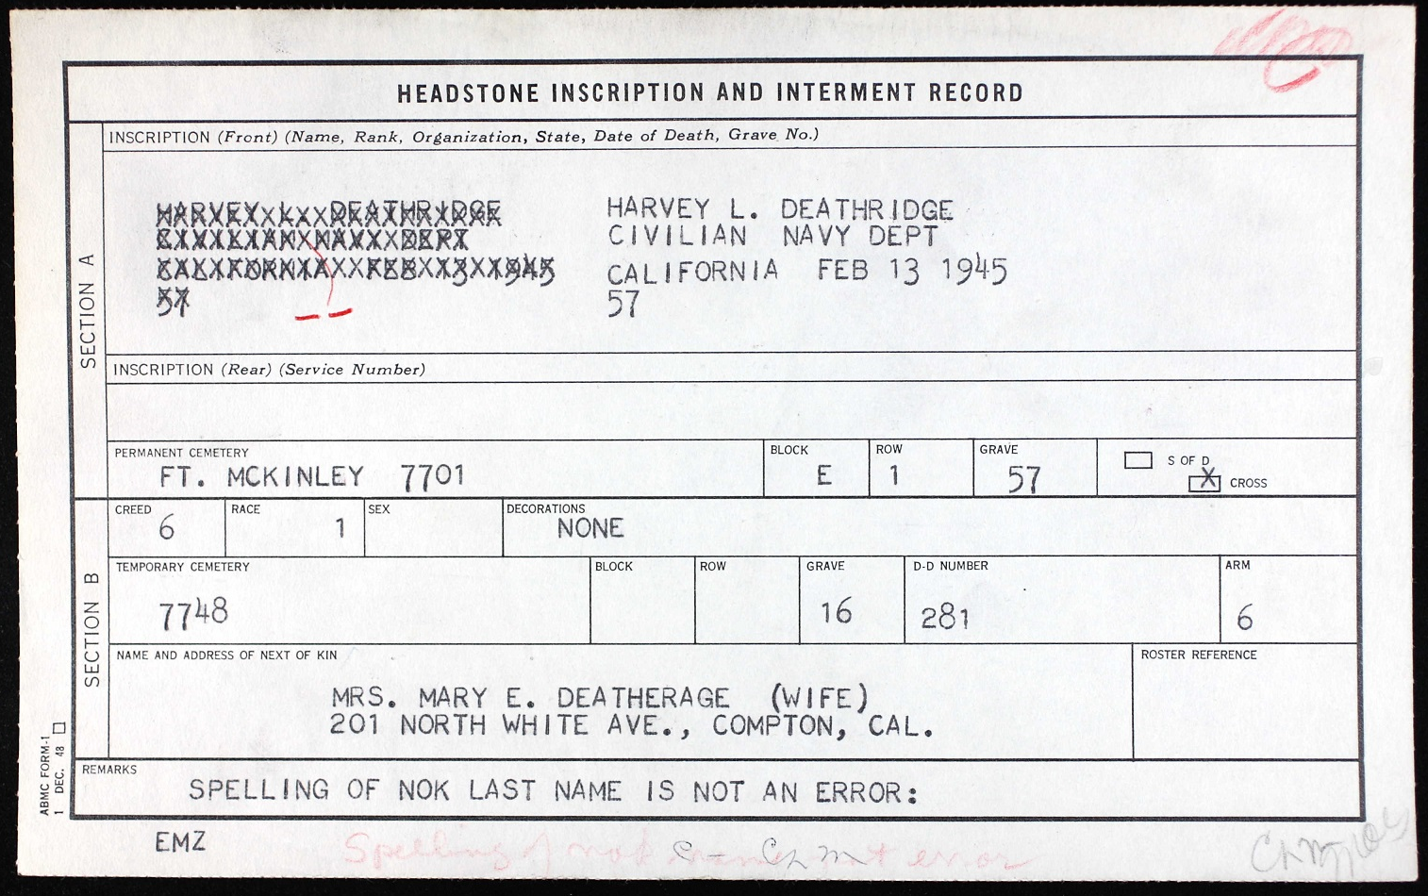

The following is the Japanese death certificate issued for Harvey.
