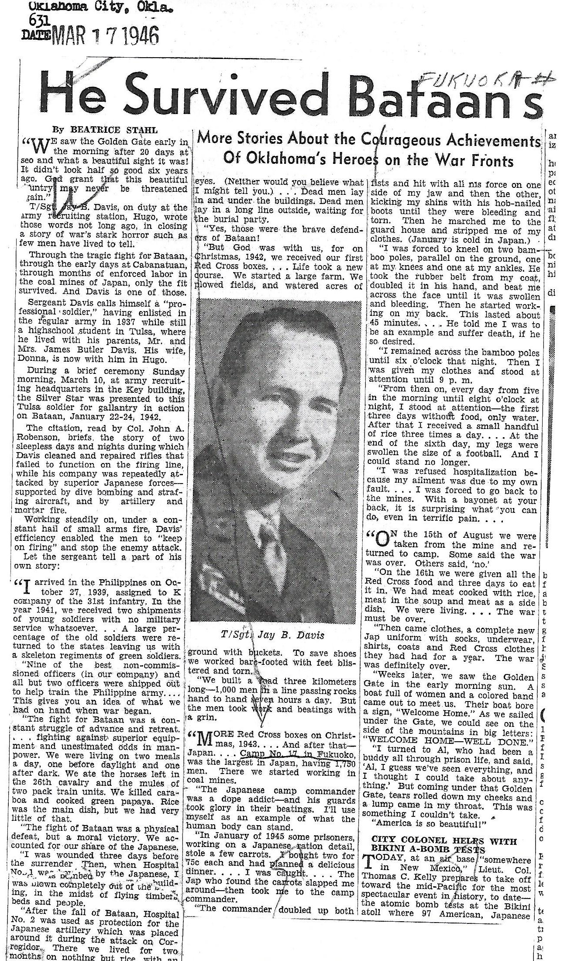
Jay B Davis

Army -
T/SGT

