Lloyd (Joe) Chalker

Australian Army - 4th Anti-Tank Regt. - Gunnar

Joe, as his friends called him, died in camp 13 June 1945. Especially tragic as the war was so close to ending. His death is also listed in the diary of fellow POW, Allen Jones.
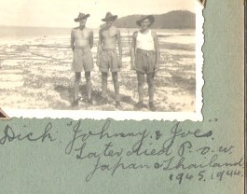
(Joe is on far right)

Death documents below and next page

