Raymond Ray Caldwell
CAC 60th CA Regt (AA) Battery K

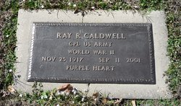

Birth: 25 Nov 1917 ~ Farmersville, Collin County, Texas, USA

Born to John Allen Caldwell (1875–1932) and Fannie Caldwell Sparks Sifford (1888–1984)

Raymond married Miriam Joyce Ferguson Caldwell (1932–1997)

Death: 11 Sep 2001 (aged 83) ~ Titus County, Texas, USA

Burial: Edwards Cemetery Mount Pleasant, Titus County, Texas, USA

