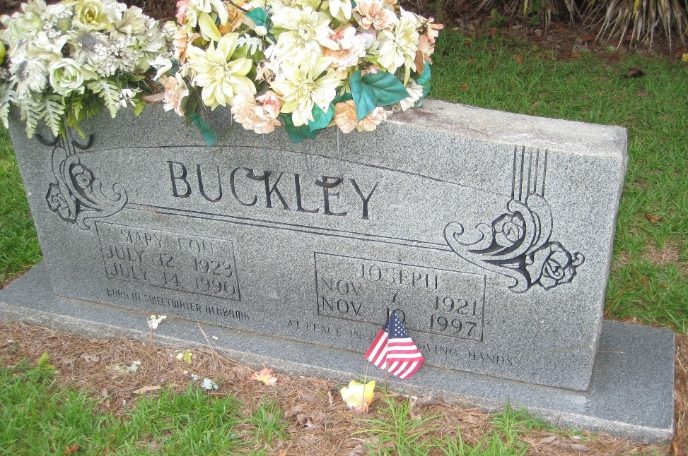
Pvt. Joesph Buckley

Memories of his uncle ~
submitted by Alan Chaney

My uncle was Army Private Joseph Buckley. He was prisoner #1281 at Camp Fukuoka Camp 17. He passed away on November 10, 1997. I have attached a photograph of his headstone. He was laid to rest at the Pleasant Ridge Baptist Church Cemetery just outside of the small town of Hickory, MS. In all of the years I knew him (from the 1960s until his retirement) he ran a dairy farm. He and his wife had one son.

I had always known that my Uncle Joe was a POW and his experience served and an inspiration for me in my own military service. However, I never talked to him about the experience when he was still living.
He is survived by one son, Billy Marshall Buckley. He and his wife had another child that died as an infant. He was one of 11 children and grew up on a farm in Hickory, MS. My mother, Jean B. Chaney, is the lone survivor of the 11. Joseph left Mississippi to go to California to find work in the late 30s/very early 40 with one of his brothers. He had four brothers that were all in uniform during WWII. My mother used to recount the story of hearing her mother get up and go out during the night. She said he followed her a couple of times and discovered that she was going out behind one of the farm buildings to pray for her boys, especially Joseph. All 5 boys survived the war. Besides Joseph’s ordeal as a POW, at least two of the others saw significant combat in Italy.
As I mentioned above, my Uncle Joe was an inspiration for me throughout my life. When I went to Army basic training and at times thought about quitting, that thought was quickly put aside as there was no way I could quit when my uncle survived 3 ½ years at the hands of the Japanese.

Even at times later in my military career when things were tough I would turn to his memory for inspiration. In my last assignment I had the privilege to command the 31st Rear Operations Center. This unit had its lineage in the 31st Infantry Division with campaign streamers from Mindanao and Southern Philippines. When I gave my parting speech to the unit I reminded them that they represent more than just the current military, that they represented the lineage of the soldiers who earned those streamers.

Thank you so much for running the website and keeping the memory of these men alive.

Alex Chaney ~ 2011

