Remembering the Bataan Air Force

By Lt Col Terrence G. Popravak, Jr., USAF (Retired)

In the Philippines Islands seventy years ago, on April 9, 1942, the Battling Bastards of Bataan were forced by starvation, disease and dearth of combat power to surrender to the stronger forces of Imperial Japan. Although this bitter defeat was a tough chapter in our military history, we can be proud of the accomplishments of the valiant Filipino-American forces on Bataan during the hard-fought campaign. It was the only significant delay to the enemy’s timetable for conquest in the early days of the war in the Pacific. We gleaned invaluable lessons from that difficult experience which helped our armed forces successfully return to the Philippines some two and a half years later. The Bataan Air Force, composed of a variety of Airmen and units of the depleted Far East Air Force, operated a small number of aircraft with which it established a record of sacrifice and achievement we should all remember and honor.

With eighteen Curtiss fighters they began the hard campaign,
On one day halved in number but flew on to play the game
For keeps, to fly and fix worn fighter ships, in tropic heat and dust,
Outnumbered but they bought us time with their sweat and blood.

From fields of dry paddies carved at Orani and Pilar they soared,
Then from Bataan, Cabcaben and Mariveles the piston engines roared.
Unnamed ground crews worked so hard, their miracles did abound,
To ensure their planes and pilots were never long on the ground.

Over Abucay Hacienda, they covered the January withdrawal,
Over the sea, beyond our lines to scout enemies large and small,
To find the foe determined to push them from the jungled land,
They brought back info vital to resist the army from Japan.

Offensive flights at day and night were few but bold and aggressive,
And caught the enemy by surprise who thought we were defensive,
Suppressed their air at Manila ‘dromes with nighttime strafing runs,
And their ships at Subic Kibosh clobbered ‘til the setting of the sun.

Distinguished defense also, as when Villamor flew by day,
To locate enemy artillery on the south side of Manila Bay.
The P-40 escorts guarding his biplane battled enemy pursuit,
So he could focus on the job, get the photos, complete his route.

A Bellanca, Waco, Beech and Duck composed the Bamboo Fleet,
Dodged enemy patrols in nighttime flights to help stave off defeat,
To gather from the islands south food and medicines to ease the pain,
Of Bataan’s men and women caught behind the blockaded supply chain.

And on the ground the plane-less squadrons did their part as well,
In the Battle of the Points they gave the sea-borne invaders hell,
Stood fast on the Orani line ‘til the tanks outflanked their post,
In perhaps the fiercest battles that an Airman would ever know.

To those who perished in the battles or that brutal Death March,
To the lost in the camps or from Hell Ships never disembarked,
We salute you for your valor in the brave stand that you made,
And thank you for the forlorn sacrifice for freedom that you gave.

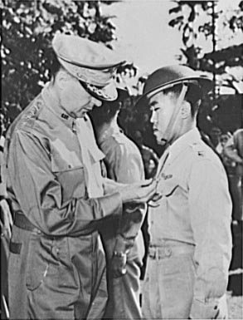
Manila, the Philippine Islands. In one of the last pictures to leave the Philippines before Manila fell to the Japs, General Douglas MacArthur (left) is shown pinning a Distinguished Service Cross on Captain Jesus A. Villamor, of the Philippine Air Force, for heroism in the air. In the center background is Lieutenant Jack Dale, of the U.S. Army.

